Upcoming Traffic Impact: Kimridge Ave.
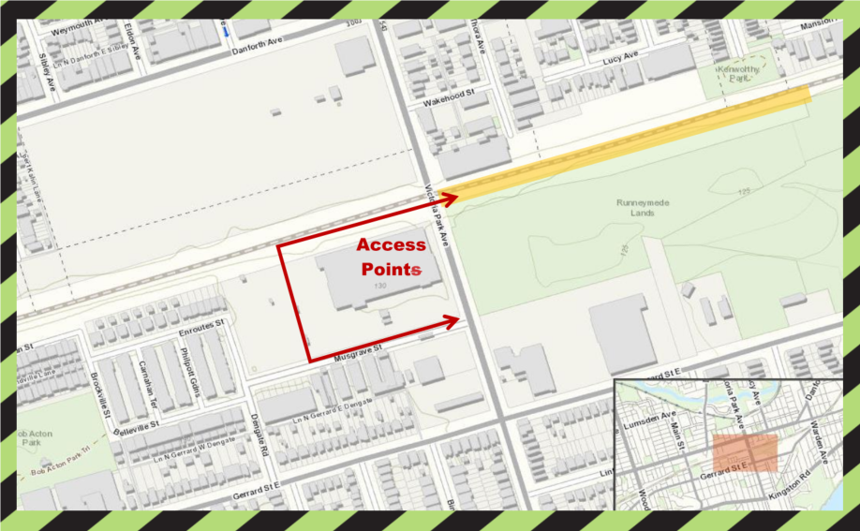
As early as Feb 3, 2023 to December 2023
Work Area
Two Narrow Lanes Maintained Along Kimridge Ave.

What work is taking place?
In early February, Metrolinx contractors will be occupying a portion of the south lane at Kimridge Avenue. Initially, crews will be using this area as an access point into the corridor to support construction of a drill pad at Danforth Bridge. Once work on the drill pad is complete, the access along Kimridge Ave. will be used during construction of Retaining Wall 10. A summary of all construction activities in the area, along with the anticipated durations for each, has been included below.
Construction Activities | Scheduled Start Date | Expected Duration | Hours of Work | What to Expect
Street Occupancy at Kimridge Ave. | As early as Feb 3, 2023 | Approx. 4 months | Day and Night Shift | Construction of a drill pad to support the temporary shoring required at Danforth Bridge (east abutment). Both the north and south lanes of Kimridge Ave. will remain open to traffic, though the lanes will be narrowed as outlined above. Equipment for this work includes an excavator, dozer, dump trucks, and a packer.
Retaining Wall 10 | April 2023 | Approx. 6 months | Day Shift | The partial street occupancy at Kimridge Ave. will continue to support the construction of the retaining wall. Equipment for this work includes an excavator, dump trucks, concrete trucks, and concrete pump.

Construction Activities | Scheduled Start Date | Expected Duration | Hours of Work | What to Expect
Electrical Raceway Installation | August 2023 | Approx. 2 months | Day and Night Shift | The partial street occupancy at Kimridge Ave. will continue to support the underground installation of electrical conduit for the future track electrification. Equipment for this work includes an excavator and packers.
Landscaping and Restoration | October 2023 | Approx. 3 months | Day Shift | Restoration of disturbed areas, including final grading, tie-ins, topsoil placement, fence installation, and hydroseeding. Equipment for this work includes mini excavators, dump trucks, and water trucks.
* Please note that dates and times are approximate and work could be rescheduled
* Please note that weekend work may be required
What to Expect
Residents should expect some noise, vibration, dust, and site lighting. Work crews will take reasonable precautions to minimize disturbances to residents, including the following:
- No idling of non-essential equipment to reduce the accumulation of construction noise.
- Limited reverse operations and the use of white-noise backup alarms where possible.
- Pointing lights away from residential windows.
- Noise vibration monitoring will be set up to ensure that noise levels are within exposure limits.
HOURS OF WORK
- Day shift work will occur from 7:00 a.m. to 5:00 p.m., five (5) days per week (Monday to Friday).
- Night shift work will occur from 7:00 p.m. to 5:00 a.m., five (5) days per week (Sunday to Thursday).
- Work may be rescheduled due to unforeseen circumstances.
TRAFFIC & PEDESTRIAN DETAILS
- The corridor will be accessed via Kimridge Ave. (at the south end of Mystic Ave.), north of the rail corridor.
- Increased construction vehicles and equipment can be expected in the work area.
- Traffic access will be restricted along Kimridge Ave. beginning February 2023. Please refer to the image for details.
- There are no impacts to pedstrians associated with this work.
TRANSIT INFORMATION
- No impacts to TTC or other public transit modes are anticipated during this work.
OTHER INFORMATION
- For the latest information on what’s happening in your area, please e-mail TorontoEast@Metrolinx.com and ask to subscribe to our weekly e-newsletter.
- Please exercise caution around active construction sites.
PROJECT INFORMATION
- We’re making improvements today to bring you even more service in the future. Preparatory early works are underway on the Lakeshore East Rail Corridor Expansion project in Toronto. This project covers the area between Pape Avenue and Kennedy Road. Completing this work will enable the future addition of a fourth track and electrification infrastructure on the Lakeshore East line.
- Electrification is a key part of building a quieter, faster, more efficient network across the region. The new fourth track will improve journey times for all transit trips on the Lakeshore East Corridor, improve reliability and deliver more service within the City of Toronto. For more information on this project and to see all construction notices please visit metrolinx.com/lakeshoreeastrailcorridor.
Thank you for your patience as we work to transform the rail corridor in your area.

