Project Update: Remaining Construction
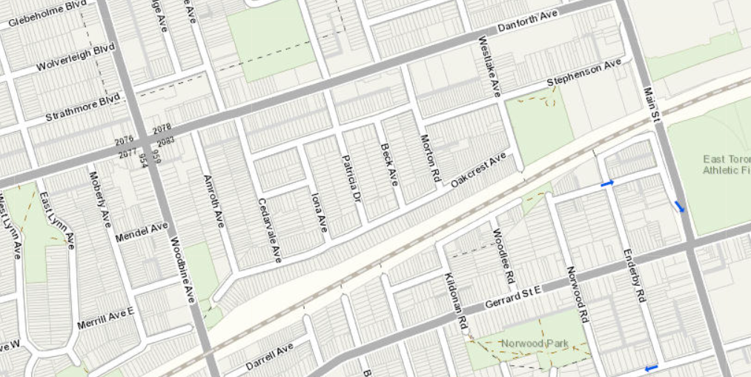
Present to December 2023
RETAINING WALL 9
RETAINING WALL 3
Access
Point
Access
Point

What work is taking place?
Metrolinx contractors have completed installation of Retaining Wall 9 along the south side of the corridor within the Metrolinx Right-of-Way, between Woodbine Avenue and Main Street. The piling work for Retaining Wall 3 has also been completed along the north side of the rail corridor and crews are excavating soil in this area to support the lagging installation. A summary of all construction activities in the area, along with the anticipated durations for each, has been included below.
Construction Activities | Scheduled Start Date | Expected Duration | Hours of Work | What to Expect
Lagging and Backfill at RW3 | Ongoing | Approx.  4 months | Day Shift | Excavation to support the installation of lagging material. Lagging installation consists of the horizontal material added between the piles of the retaining wall to hold back the earth. Equipment for this work includes excavators, dozers, and dump trucks.
Installation of Electrical Raceway and Drainage Measure at RW3 | July 2023 | Approx.  6 months | Day and Night Shift | Underground installation of electrical conduit for the future track electrification and the soakaway pit (drainage measure). Equipment for this work includes an excavator and packers.

Construction Activities | Scheduled Start Date | Expected Duration | Hours of Work | What to Expect
Installation of Drainage Measure at RW9 | May 2023 | Approx. 3 months | Day and Night Shift | Underground installation of the soakaway pit (drainage measure). Equipment for this work includes an excavator and packers.
Landscaping and Restoration | September 2023 | Approx. 3 months | Day and Night Shift | Tie-ins and restoration of disturbed areas along the north and south side of the rail corridor, including final grading activities, topsoil placement, and hydroseeding. Equipment for this work includes mini excavators, dump trucks, and water trucks.
What to Expect
Residents should expect some noise, vibration, dust, and site lighting. Work crews will take reasonable precautions to minimize disturbances to residents, including the following:
- No idling of non-essential equipment to reduce the accumulation of construction noise.
- Limited reverse operations and the use of white-noise backup alarms where possible.
- Pointing lights away from residential windows.
- Noise vibration monitoring will be set up to ensure that noise levels are within exposure limits.

HOURS OF WORK
- Day shift work will occur from 7:00 a.m. to 5:00 p.m., five (5) days per week (Monday to Friday).
- Night shift work will occur from 7:00 p.m. to 5:00 a.m., five (5) days per week (Sunday to Thursday).
- Work may be rescheduled due to unforeseen circumstances.
TRAFFIC & PEDESTRIAN DETAILS
- The corridor will be accessed from the south end of Westlake Ave, north of the rail corridor.
- Increased construction vehicles and equipment can be expected in the work area.
- Neither traffic nor pedestrians will be impacted at this time.
TRANSIT INFORMATION
- No impacts to TTC or other public transit modes are anticipated during this work.
OTHER INFORMATION
- For the latest information on what’s happening in your area, please e-mail TorontoEast@Metrolinx.com and ask to subscribe to our weekly e-newsletter.
- Please exercise caution around active construction sites.
PROJECT INFORMATION
- We’re making improvements today to bring you even more service in the future. Preparatory early works are underway on the Lakeshore East Rail Corridor Expansion project in Toronto. This project covers the area between Pape Avenue and Kennedy Road. Completing this work will enable the future addition of a fourth track and electrification infrastructure on the Lakeshore East line.
- Electrification is a key part of building a quieter, faster, more efficient network across the region. The new fourth track will improve journey times for all transit trips on the Lakeshore East Corridor, improve reliability and deliver more service within the City of Toronto. For more information on this project and to see all construction notices please visit metrolinx.com/lakeshoreeastrailcorridor.
Thank you for your patience as we work to transform the rail corridor in your area.

