Partial Intersection Closure for Track Installation at Watergarden Drive/Armdale Road and Hurontario Street

Thursday July 13, 2023, 2023 at 10 p.m., to Thursday August 10, 2023 at 10 p.m.

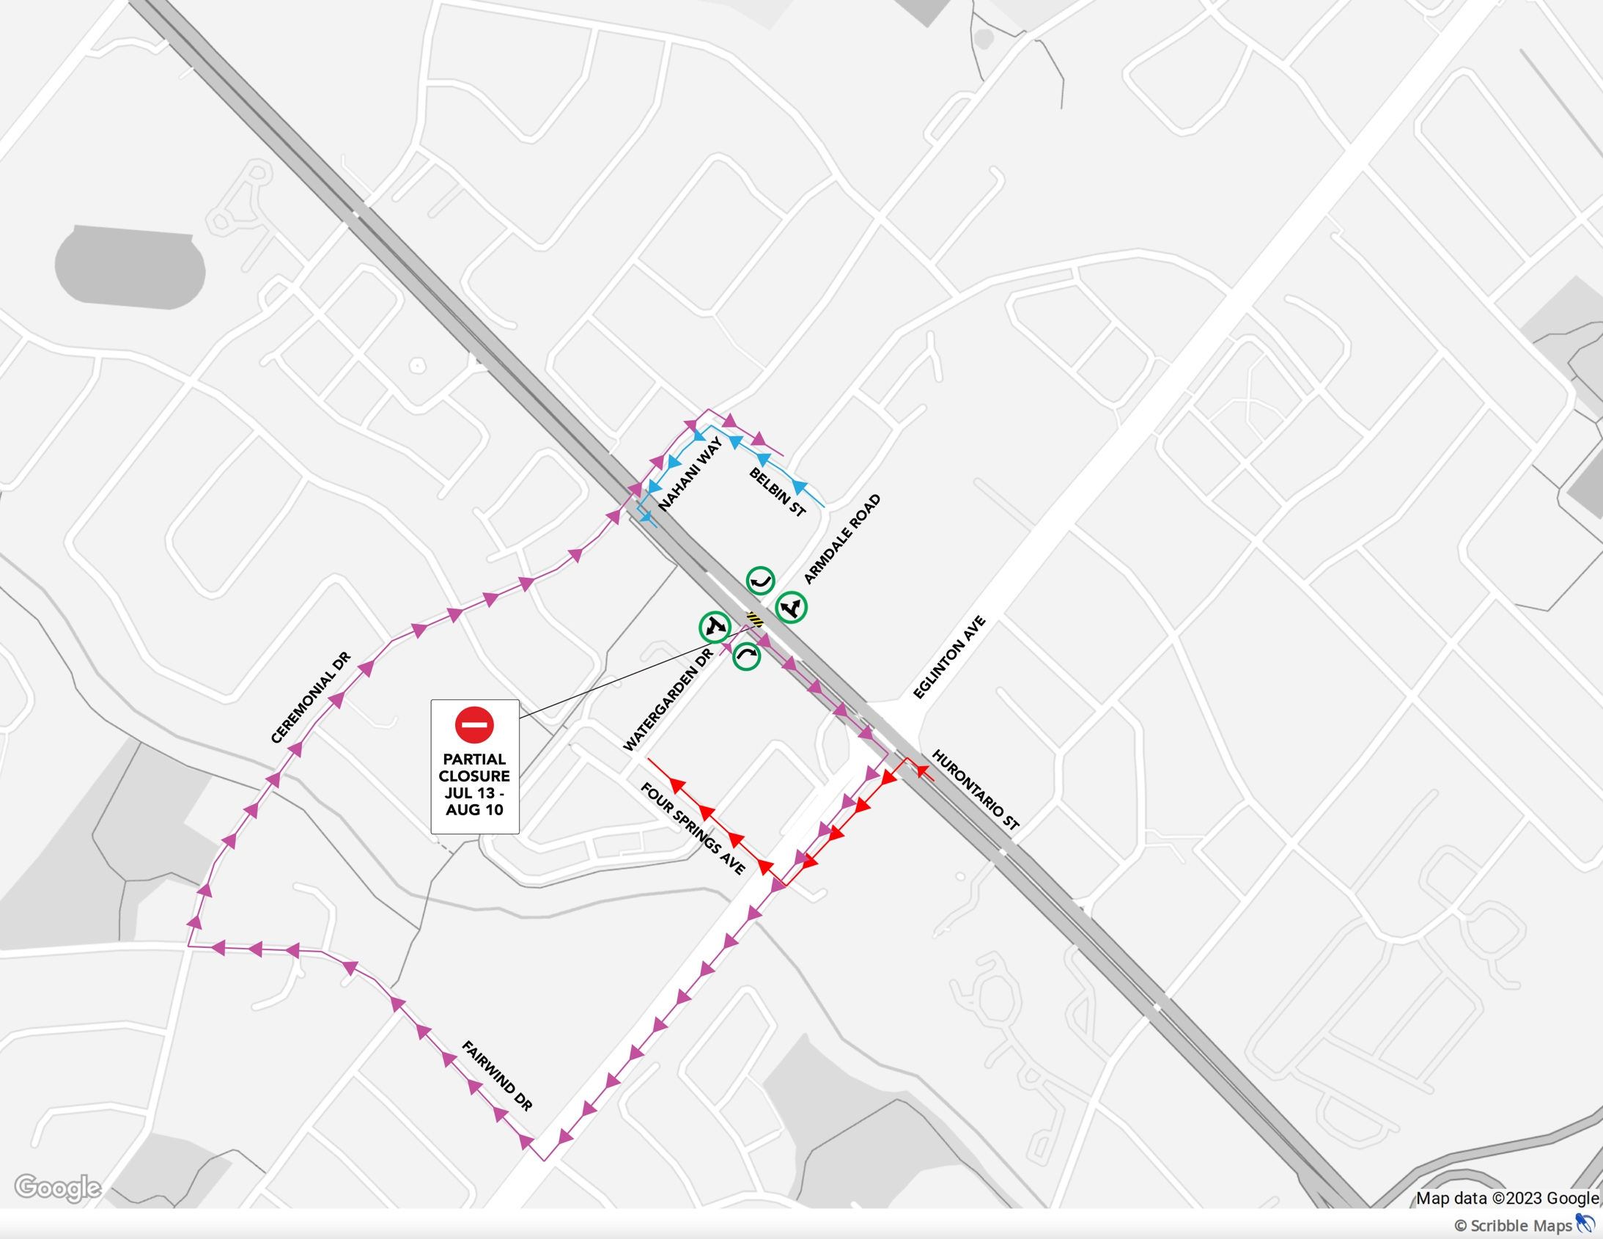



What work is taking place?

Important work to install tracks along Hurontario Street continues, requiring a left-turn restrictions at the intersection of Watergarden Drive/Armdale Road and Hurontario Street. Crews will be excavating the centre of the intersection to install tracks and pour concrete, enabling the guideway to move through intersections along Hurontario Street. The closure will take place from **Thursday July 13, 2023, at 10 p.m.** until **Thursday August 10, 2023 at 10 p.m.** Detour routes will be accessible via Ceremonial Drive/Nahani Way, Fairwind Drive and Four Springs Avenue.

Construction work at this intersection is scheduled to take place from 7 a.m. to 10 p.m. until completion. The first and last night will include overnight work to implement staging and in preparation for reopening. Access for emergency vehicles across Hurontario Street will not be maintained. Traffic signal timings will be adjusted to keep people moving. Pedestrian crossings will be maintained at a signalized crosswalk. Please follow the signs installed to assist with navigating around the closure.

In accordance with City of Mississauga Noise By-Law Exemption requirements, this notice is meant to advise that residents near the work site can expect to hear noise and vibration caused by trucks, excavators, loaders, tri-axles, backhoes, and other construction equipment related to this work.

Please note, work may be rescheduled due to weather or unforeseen circumstances. If you require the most up-to-date information, please reach out to [peel@metrolinx.com](mailto:peel@metrolinx.com) and our team will provide you with e-updates of this work.



**TIMING**

Work Watergarden Drive/Armdale Road and Hurontario Street is scheduled from July 13, 2023, until August 10, 2023.

First and last night will include overnight work to implement staging and in preparation for reopening.

Construction is scheduled to occur from 7am-10pm, including weekends.

Work could be rescheduled and delayed due to weather conditions or unforeseen circumstances.

TRAFFIC DETAILS

Eastbound and westbound movements will not be permitted across at Watergarden Drive/Armdale Road and Hurontario Street.

Lefthand turns from Hurontario Street onto Watergarden Drive/Armdale Road will not be permitted.

Access for emergency vehicles across Hurontario Street at Watergarden Drive/Armdale Road will not be maintained.

Traffic delays are expected.

Temporary traffic signal heads will be bagged to align with the lane closures.

Watch for slow moving vehicles entering and exiting work areas.

Remember to reduce your speed when approaching lane reductions.

TRANSIT IMPACT DETAILS

Visit MiWay.ca, BramptonTransit.com and gotransit.com for updates on your bus route.

Watch for additional signs directing passengers at bus stops as boarding areas may be relocated.

WHAT TO EXPECT?

Every effort will be made to minimize disruptions.

Access to properties will be maintained.

Residents and businesses near the work site can expect to hear noise caused by trucks, excavators, backhoes, and other construction equipment related to this work.

PEDESTRIAN DETAILS

Please take care when walking or cycling near construction areas and watch for additional signs directing the public such as detours and dismounting.

Watch for additional signs directing pedestrians across Hurontario Street as only one east/west crosswalk will be provided at all Hurontario Street intersections.

CONTACT US

Metrolinx has a dedicated community relations team in place to work with residents in Peel region through the construction and operation of this transformational transit project.

24-hour line: 416-202-7500