Left turn restrictions at Mineola Road and Hurontario Street

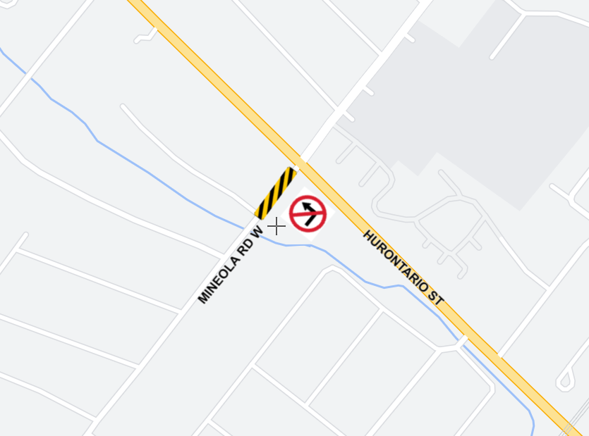Saturday, May 4, 2024 from 7 a.m. to 10 p.m.



What work is taking place?

Crews will be doing emergency repairs to sanitary pipes at the intersection of Mineola Road West and Hurontario Street on **Saturday May 4, 2024 from 7 a.m. to 10 p.m.** During this work, east bound traffic from Mineola Road West will not be able to make left turns at the intersection of Mineola Road West and Hurontario Street.

In accordance with City of Mississauga Noise By-Law Exemption requirements, this notice is meant to advise that residents near the work site can expect to hear noise and vibration caused by trucks, excavators, loaders, tri-axles, backhoes, and other construction equipment related to this work.

Please note, work may be rescheduled due to weather or unforeseen circumstances. Please see roadway signage for the latest information. If you require the most up-to-date information, please reach out to [peel@metrolinx.com](mailto:peel@metrolinx.com) and our team will provide you with e-updates of this work.



TIMING

Emergency sanitary repairs are scheduled on May 4, 2024.

Construction is scheduled to occur from 7 a.m. – 10 p.m.

Work could be rescheduled and delayed due to weather conditions or unforeseen circumstances.

TRAFFIC DETAILS

East bound traffic on Mineola Road West will not be able to make left turns at Hurontario Street will not be permitted.

Traffic delays are expected.

Watch for slow moving vehicles entering and exiting work areas.

Remember to reduce your speed when approaching lane reductions.

WHAT TO EXPECT?

Every effort will be made to minimize disruptions.

Residents and businesses near the work site can expect to hear noise and vibration caused by trucks, excavators,

loaders, tri-axles, backhoes, and other construction equipment related to this work.

PEDESTRIAN DETAILS

Please take care when travelling near construction areas.

Sidewalk access in the area could be affected.

Watch for additional signs directing pedestrians as detours may be required.

Clear and defined walking paths will be maintained during construction to ensure pedestrian safety.

PROPERTY DETAILS

Crews will not require property access for this work.

CONTACT US

Metrolinx has a dedicated community relations team in place to work with residents in Peel region through the construction and operation of this transformational transit project.

24-hour line 416-202-7500.