**CONSTRUCTION LIAISON COMMITTEE UPDATE**

*Brampton South*

May 2021

Thank you for being part of the Hurontario LRT Construction Liaison Committee.

We will be providing our CLC members with a digital update this month (see below).

Our team is virtually engaging with our committee members and broader public as the Covid-19 restrictions continue.

Our next virtual update will be scheduled for June 2021.

**ONGOING CONSTRUCTION:**

**Operations Maintenance Storage Facility**

Works continue to progress smoothly at the OMSF, including the installation of plumbing, heating, and electrical infrastructure to supply utility services to the building, while the roof and exterior walls of the maintenance building is underway.

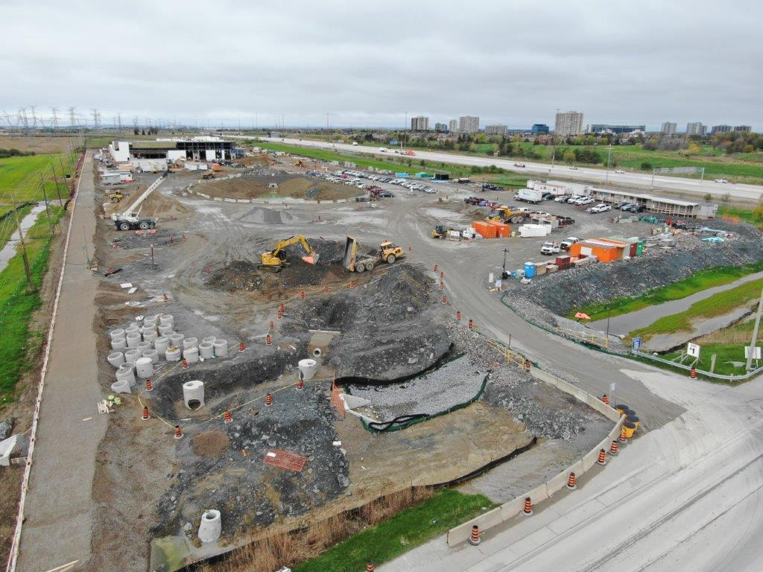

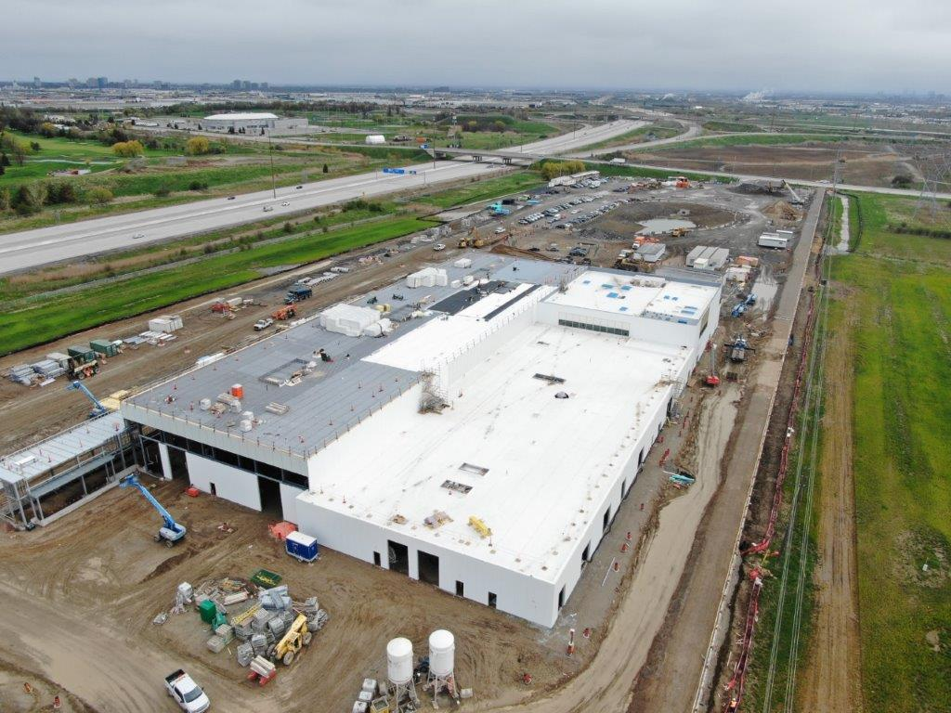

**UPCOMING WORKS:**

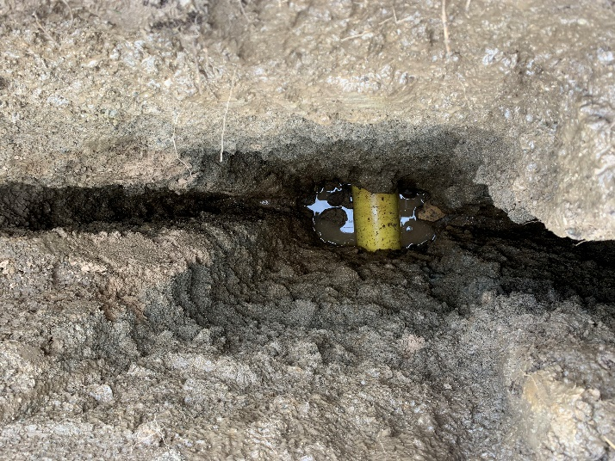**Sub-Surface Utility Engineering (SUE) Investigations**

SUE Investigations involve creating test pits to expose and map the locations of existing buried utilities. This helps to inform the construction methodology, prior to excavations and utility works taking place in the area and is used to minimize service disruptions to adjacent properties. SUE investigations between County Court Boulevard and Bartley Bull Parkway are expected to begin in June.

**SPRING 2021 VIRTUAL ENGAGEMENT:**

Join us at [metrolinxengage.com/HuLRT](https://www.metrolinxengage.com/en/engagement-initiatives/hurontario-light-rail-transit-project) as we provide project updates and an overview of the construction schedule for the remainder of the year. Ask questions directly to our team of experts through our “Ask Us” section, and your questions will be answered by a member of the project team.



**SAFETY**

Safety is our number one priority and a shared responsibility. Please note and follow construction signage as you walk, cycle or drive along Hurontario Street. If you have any questions or concerns, please feel free to reach out to Metrolinx Community Relations team at 416-202-7500 or email [Peel@metrolinx.com](mailto:Peel@metrolinx.com)

For more updates and information on this project, and to get the latest news on what’s happening in Peel, subscribe to our newsletter: [www.metrolinx.com/hurontariolrt](http://www.metrolinx.com/hurontariolrt)