**CONSTRUCTION LIAISON COMMITTEE UPDATE**

*Cooksville*

May 2021

Thank you for being part of the Hurontario LRT Construction Liaison Committee.

We will be providing our CLC members with a digital update this month (see below).

Our team is virtually engaging with our committee members and broader public as the Covid-19 restrictions continue.

Our next virtual update will be scheduled for June 2021.

**ONGOING CONSTRUCTION:**

**Enbridge Gas Line Relocation on the Queensway and Hurontario Street**

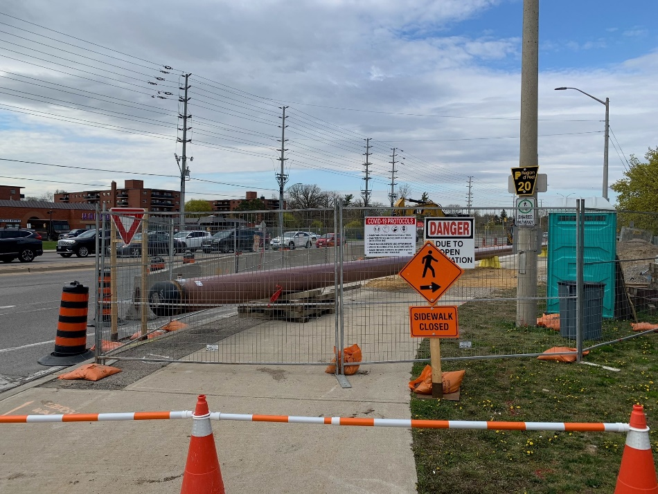To accommodate construction of the Hurontario LRT, Enbridge Gas is required to relocate a natural gas line on Queensway West at Hurontario Street. The pipeline is integral to Enbridge’s natural gas system and must be re-routed to ensure the safe and reliable delivery of natural gas to customers in the Greater Toronto Area. This work began in April and expected to be completed in July.

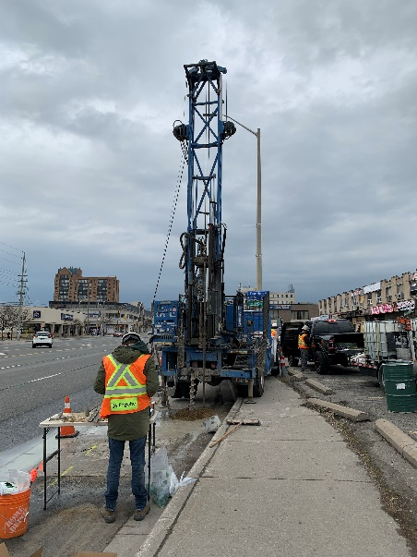**Sub-Surface Utility Engineering (SUE) Investigations**

SUE Investigations involve creating test pits to expose and map the locations of existing buried utilities. This helps to inform the construction methodology, prior to excavations and utility works taking place in the area and is used to minimize service disruptions to adjacent properties. SUE investigations between the Queensway and Fairview Road will continue in June.

**Temporary Traffic Signals & Median Removals at Intersections**

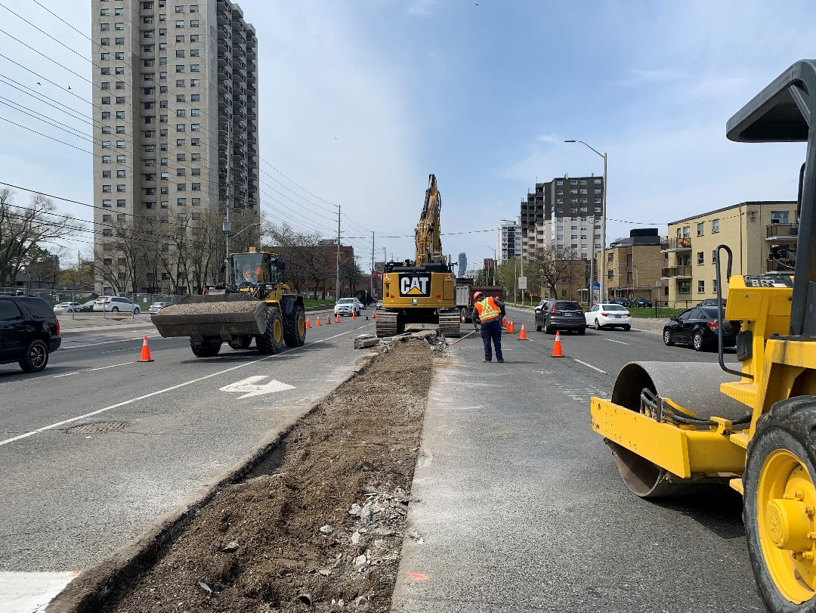The removal of medians at intersections and the installation of temporary traffic signals are ongoing. Median removals continue between Bronte College Court and Matthews Gate and the installation of temporary signals continue between Bronte College Court and Fairview Road. While crews will use the boulevard to avoid lane closures, there may be temporary right lane closures for up to four hours to accommodate the work**.**

**Utilities and Roadways:**

Beginning in June, site preparation for utility relocations and civil works for roadways are expected in to take place between North Service Road (QEW) and Matthews Gate. This involves removal of any remainder medians, full energization of temporary traffic signals, followed by line painting and setting up temporary fencing and bus platforms.

**SPRING 2021 VIRTUAL ENGAGEMENT:**

Join us at metrolinxengage.com/hulrt as we provide project updates and an overview of the construction schedule for the remainder of the year. Ask questions directly to our team of experts through our “Ask Us” section, and your questions will be answered by a member of the project team.

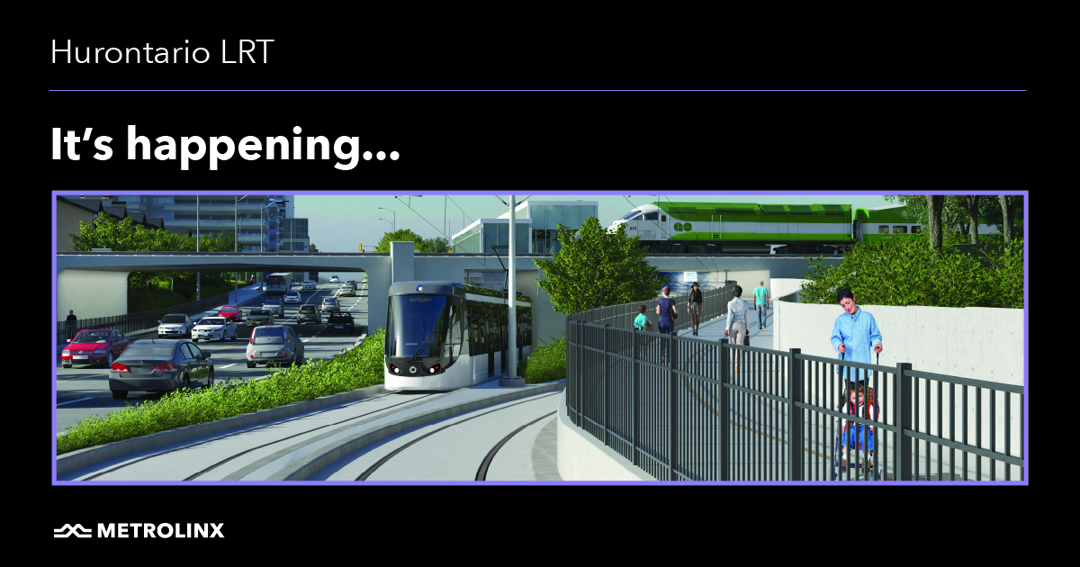

**SAFETY**

Safety is our number one priority and a shared responsibility. Please note and follow construction signage as you walk, cycle or drive along Hurontario Street. If you have any questions or concerns, please feel free to reach out to Metrolinx Community Relations team at 416-202-7500 or email [Peel@metrolinx.com](mailto:Peel@metrolinx.com)

For more updates and information on this project, and to get the latest news on what’s happening in Peel, subscribe to our newsletter: [www.metrolinx.com/hurontariolrt](http://www.metrolinx.com/hurontariolrt)