**CONSTRUCTION LIAISON COMMITTEE UPDATE**

*Mississauga South*

May 2021

Thank you for being part of the Hurontario LRT Construction Liaison Committee.

We will be providing our CLC members with a digital update this month (see below).

Our team is virtually engaging with our committee members and broader public as the Covid-19 restrictions continue.

Our next virtual update will be scheduled for June 2021.

**ONGOING CONSTRUCTION:**

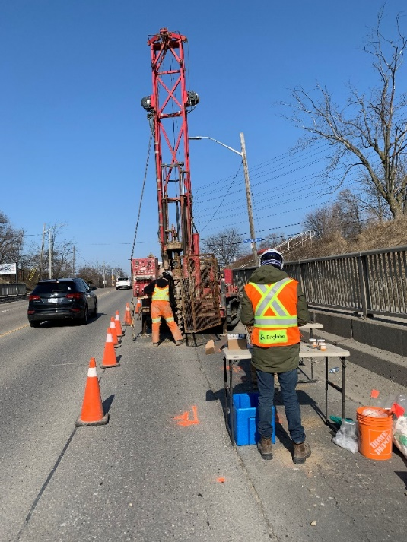**Environmental and Geotechnical Borehole Investigations:**

The drilling of boreholes for environmental and geotechnical investigations continues into the month of June between Park Street and the QEW. Environmental investigations analyze the quality of the soil in the area to check for contaminants and determine which facility the excavated soil should be hauled away to during construction. Geotechnical tests identify the type of soil which helps with design of LRT foundation. These investigations gather data on the ground conditions specific to the area and helps to inform the site-specific construction methodology and advance the design process, prior to construction taking place.

**Median Removals, Utility and Road Works:**

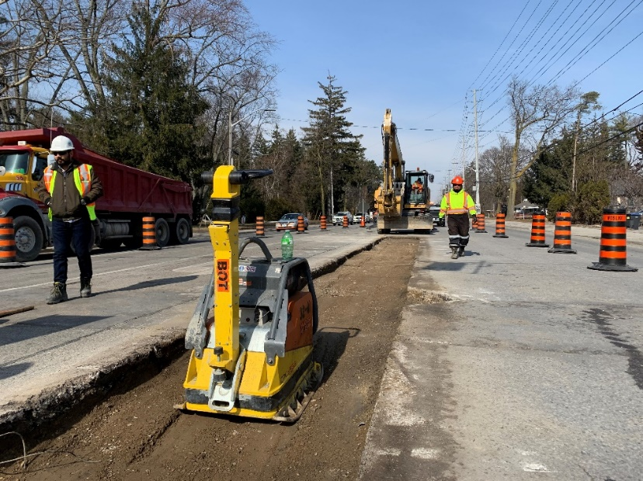Median removals on QEW right of way are planned for early June, to prepare for utility and road widening works set to begin later this year. In advance of utility works on the east side of Hurontario, line painting between Park Street and Pine Tree Way is expected to take place in June. Combined with the temporary traffic signals that were installed and activated over the past couple of months, this work is done to shift active lanes of traffic to the west side of Hurontario. Once temporary fencing and bus platforms are set up to accommodate utility works and road widening on the east side of Hurontario, one lane of traffic in each direction will be maintained on the west side of Hurontario during construction. Roadway preparations will occur over night.

**Tree Protections, Trimming, and Removals:**

Tree protections continue to be installed between Park Street and Eaglewood Boulevard. This will be followed by the trimming and removal of trees on public lands that have been identified by a qualified arborist this month. We will be in contact with private property owners regarding the trees that require trimming and/or removal on their property over the next couple of weeks.

**Mary Fix Creek:**

Construction of floodwalls continues at Mary Fix Creek. The work began on the south side of the creek. Once completed, the creek will be diverted to the south side using sandbags to maintain the flow of water, so that crews can begin floodwall construction on the north side. This staged approach to floodwall construction minimizes any negative environmental impact on the creek.

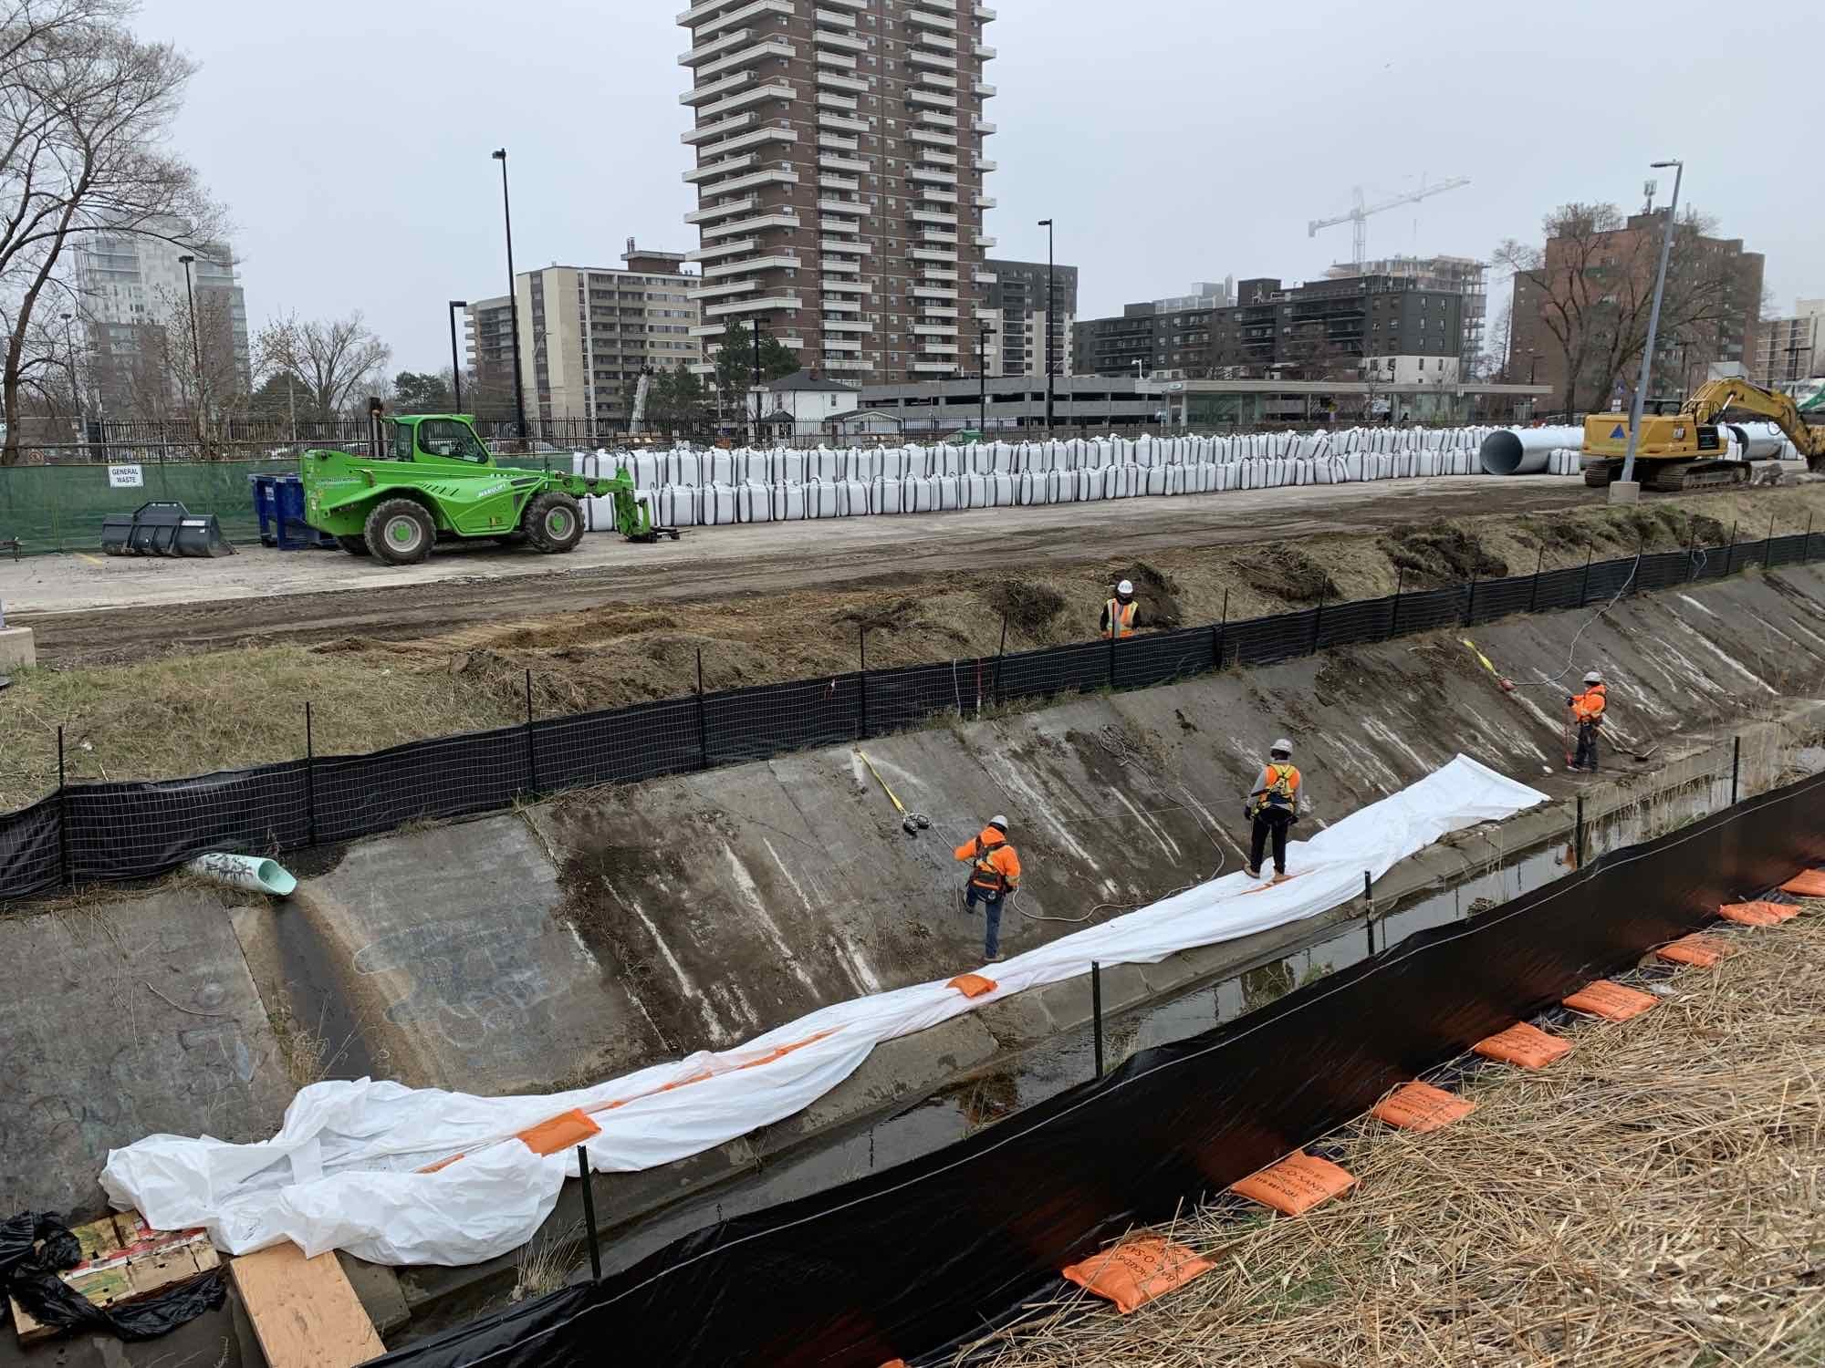

**Troy Street and Oriole Avenue Laydown Areas:**

Site preparation has begun for Troy Street and Oriole Avenue laydown areas. This involves, tree protections, removals, and grading the soil to make the area level for the storage of construction materials and equipment.

**Port Credit GO Station:**

In the south parking lot, excavation and shoring work continues by digging a trench and installing structural supports at the eastern portion of the parking lot where the LRT station will be built. This is done while crews continue to dig down to the level where the station will be built.

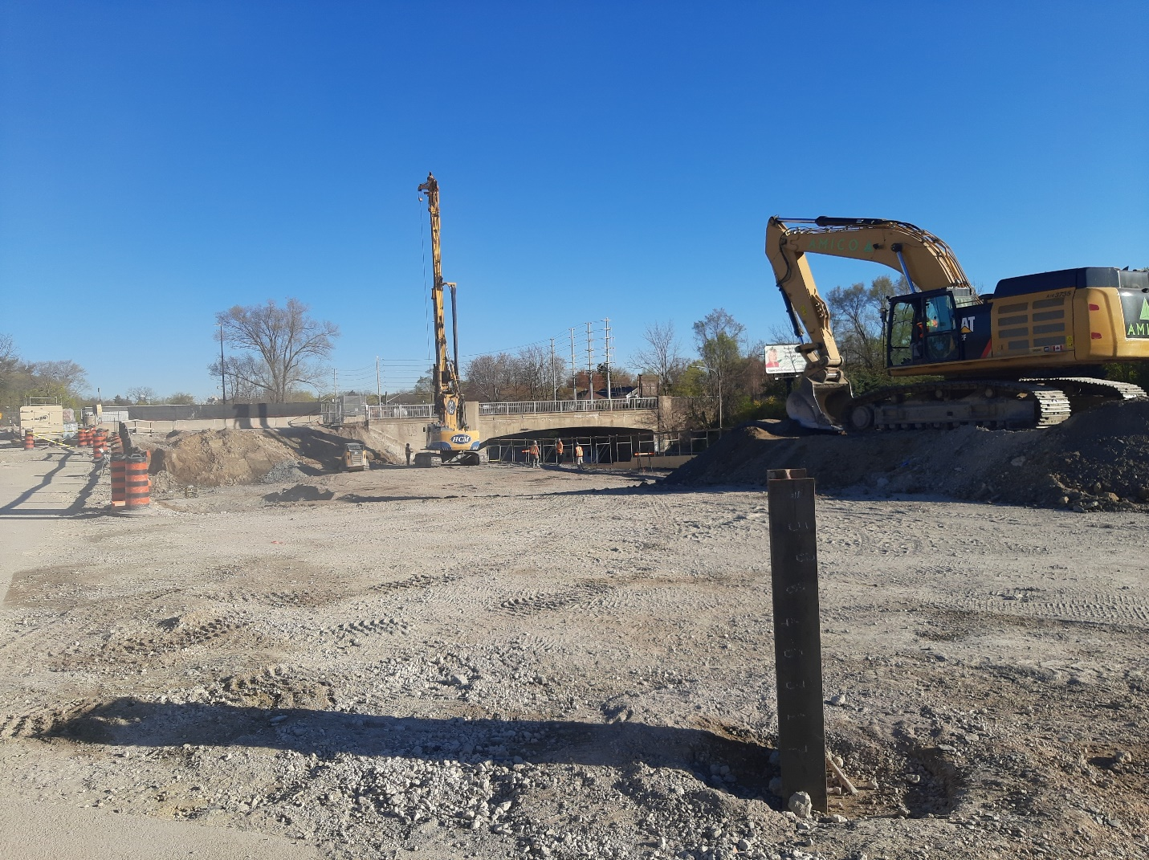

**SPRING 2021 VIRTUAL ENGAGEMENT:**

Join us at [metrolinxengage.com/HuLRT](https://www.metrolinxengage.com/en/engagement-initiatives/hurontario-light-rail-transit-project) as we provide project updates and an overview of the construction schedule for the remainder of the year. Ask questions directly to our team of experts through our “Ask Us” section, and your questions will be answered by a member of the project team.

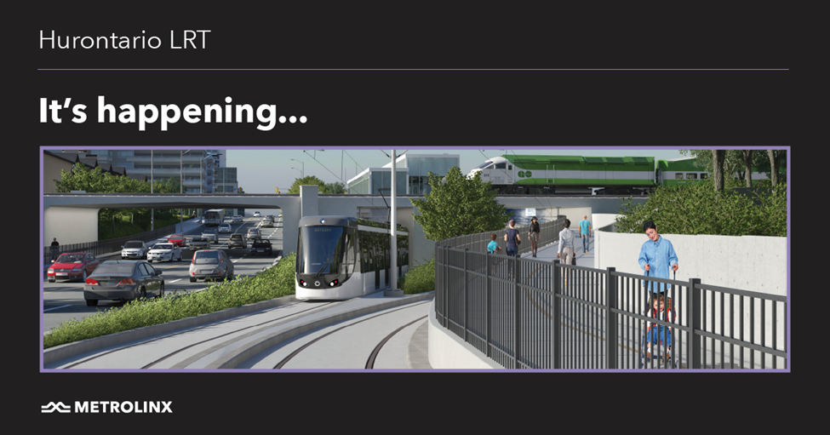

**SAFETY**

Safety is our number one priority and a shared responsibility. Please follow construction signage as you walk, cycle or drive along Hurontario Street. If you have any questions or concerns, please feel free to reach out to Metrolinx Community Relations team at 416-202-7500 or email [Peel@metrolinx.com](mailto:Peel@metrolinx.com)

For more updates and information on this project, and to get the latest news on what’s happening in Peel, subscribe to our newsletter: [www.metrolinx.com/hurontariolrt](http://www.metrolinx.com/hurontariolrt)