**CONSTRUCTION LIAISON COMMITTEE UPDATE**

*Mississauga Centre*

May 2021

Thank you for being part of the Hurontario LRT Construction Liaison Committee.

We will be providing our CLC members with a digital update this month (see below).

Our team is virtually engaging with our committee members and the broader public as the Covid-19 restrictions continue.

Our next virtual update will be scheduled for June 2021.

**ONGOING CONSTRUCTION:**

**Temporary Traffic Signals:**

Motorists, cyclists, and pedestrians will also continue to see the installation of temporary traffic signals along Hurontario Street between Burnhamthorpe Road and Eglinton Avenue over the next few weeks. While crews will use the boulevard to avoid lane closures, there may be temporary right lane closures for up to four hours to accommodate the work.

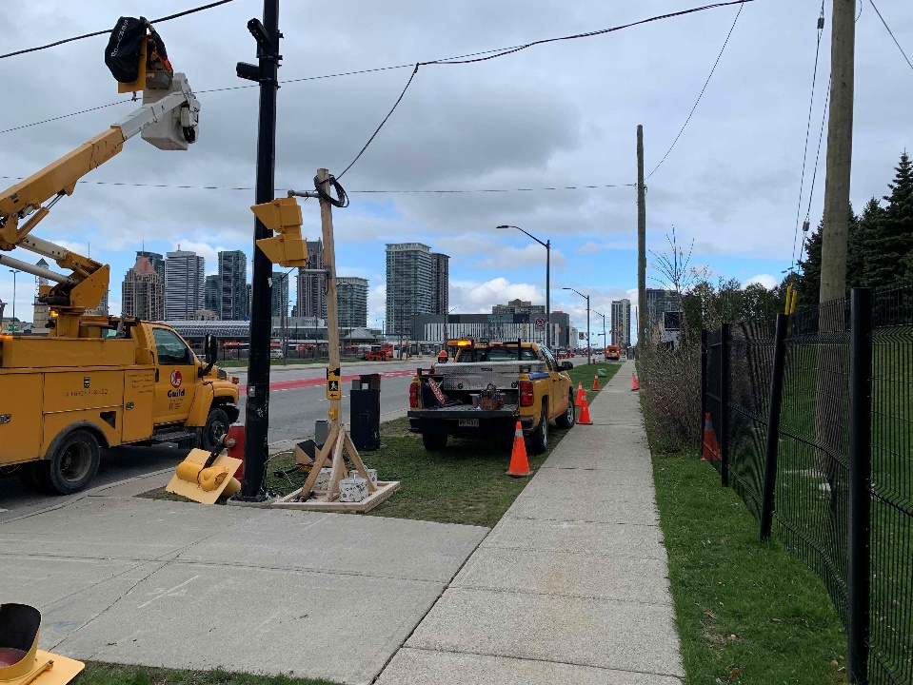

**Geotechnical Investigations and Sub-Surface Utility Engineering SUE:**

Geotechnical investigations and SUE involve drilling boreholes and creating test pits to gather information on the ground conditions specific to the area and helps to map the locations of existing utilities. This helps to inform the construction methodology and advance the design process, prior to excavations and utility works taking place in the area. Geotechnical and SUE investigations will continue in the HWY 403 area into the month of June.

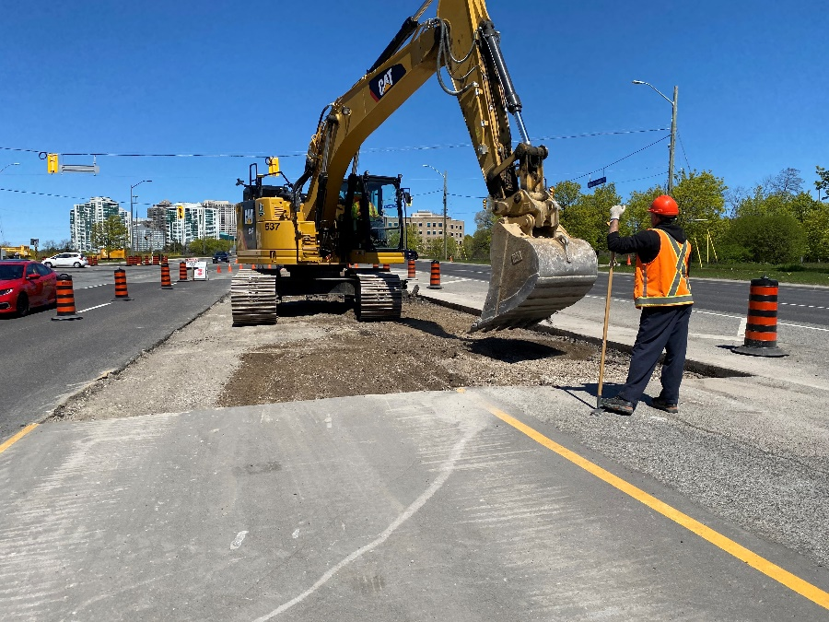

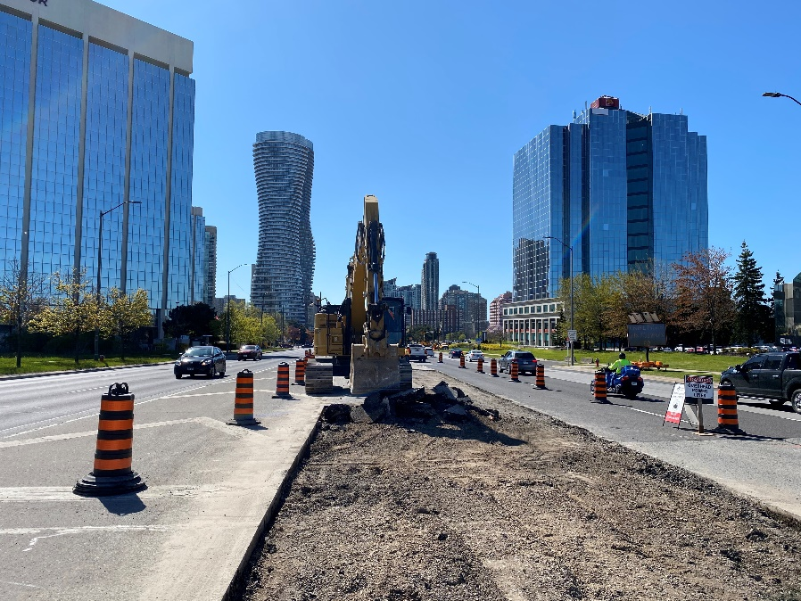

**Utilities and Roadways:**

Site preparation for utility relocations and civil works for roadways have begun between Matthews Gate and Eglinton Avenue. This involves the removal of medians and the installation of temporary traffic signals and allows us to shift active lanes of traffic to one side of the road, minimizing traffic impacts, while utility works take place along the other side of the road. The removal of medians will continue near Square One Drive and on Rathburn Road in June and staging for utility works along Hurontario are expected to begin in July.

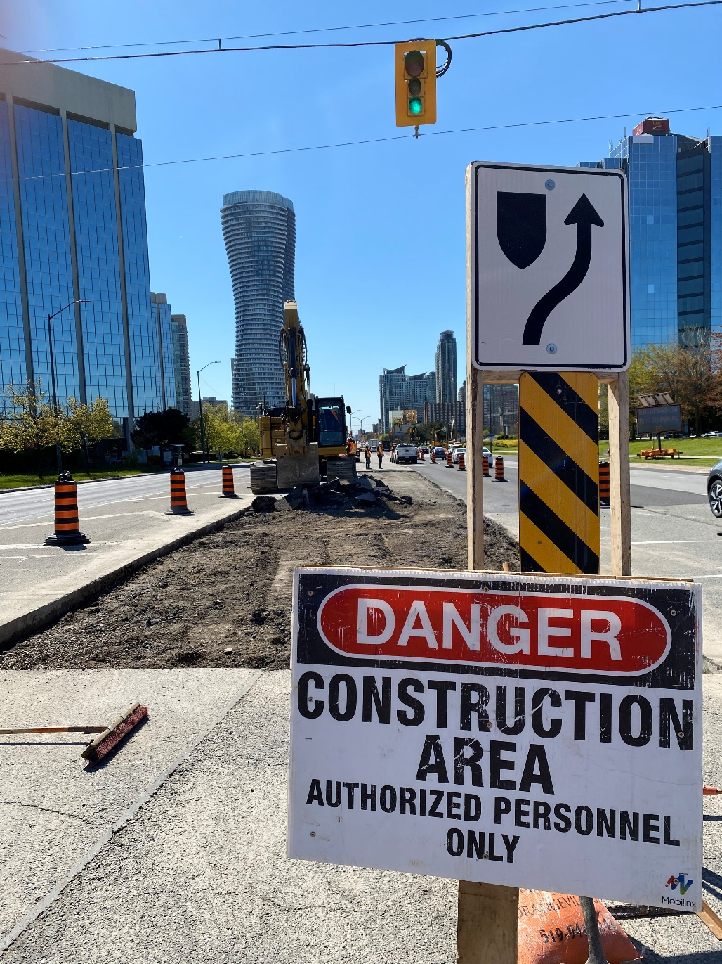

**SPRING 2021 VIRTUAL ENGAGEMENT:**

Join us at [metrolinxengage.com/HuLRT](https://www.metrolinxengage.com/en/engagement-initiatives/hurontario-light-rail-transit-project) as we provide project updates and an overview of the construction schedule for the remainder of the year. Ask questions directly to our team of experts through our “Ask Us” section, and your questions will be answered by a member of the project team.

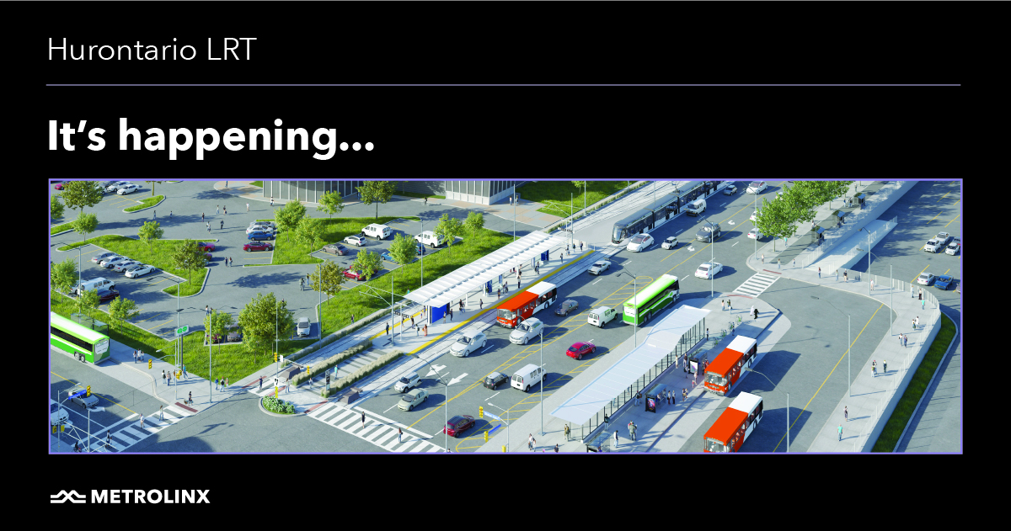

**SAFETY**

Safety is our number one priority and a shared responsibility. Please note and follow construction signage as you walk, cycle or drive along Hurontario Street. If you have any questions or concerns, please feel free to reach out to Metrolinx Community Relations team at 416-202-7500 or email [Peel@metrolinx.com](mailto:Peel@metrolinx.com)

For more updates and information on this project, and to get the latest news on what’s happening in Peel, subscribe to our newsletter: [www.metrolinx.com/hurontariolrt](http://www.metrolinx.com/hurontariolrt)