**CONSTRUCTION LIAISON COMMITTEE UPDATE**

*Mississauga North*

May 2021

Thank you for being part of the Hurontario LRT Construction Liaison Committee.

We will be providing our CLC members with a digital update this month (see below).

Our team is virtually engaging with our committee members and broader public as the Covid-19 restrictions continue.

Our next virtual update will be scheduled for June 2021.

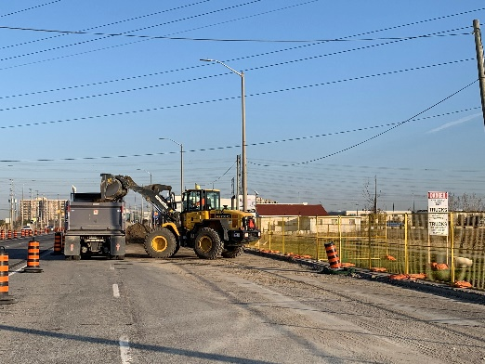**ONGOING CONSTRUCTION:**

**Utility and Road Work**

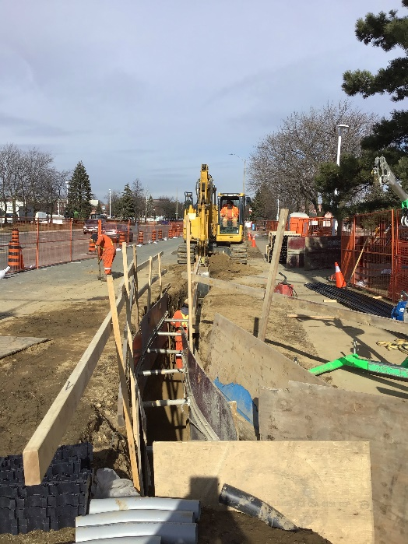The installation of watermain, storm water, sewage and sanitation are ongoing between Matheson Boulevard and HWY 407. As utility works continue, post-construction CCTV investigations are conducted to inspect the quality of the work. These inspections are currently taking place near the Matheson Boulevard and Hurontario Street intersection. The relocation of dry utilities, including telecommunications and electrical infrastructure, is also ongoing between Matheson Boulevard and Derry Road. As utility works wrap up on the east side of Hurontario Street, road widening work is expected to begin between Matheson Boulevard and Watline Avenue in June, prior to utility works beginning along the other side of the street. As this work progresses, temporary sidewalk and driveway closures will be scheduled. Once dates are confirmed, owners of the impacted properties will be informed in advance and signs will be posted to direct pedestrians and motorists.

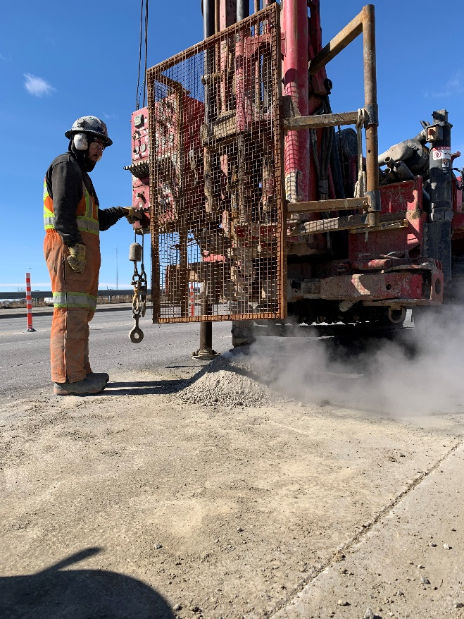**Environmental, Geotechnical Investigations and Sub Surface Utility Engineering (SUE) Test Pits:**

The drilling of boreholes for environmental and geotechnical investigations and the creation of test pits for SUE continues into the month of June near HWY 403, Admiral Boulevard, and Topflight Drive. Environmental investigations analyze the quality of the soil in the area to check for contaminants and determine which facility 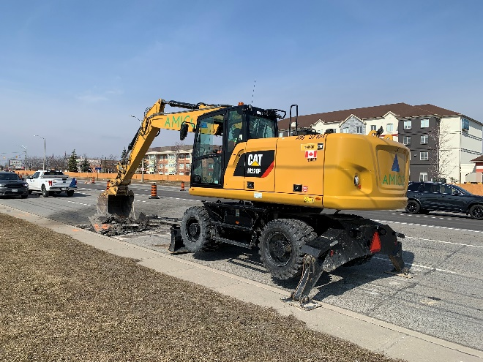the excavated soil should be hauled away to during construction. Geotechnical tests identify the type of soil which helps with design of LRT foundation. These investigations gather data on the ground conditions specific to the area and helps to inform the site-specific construction methodology and advance the design process, prior to construction taking place. SUE Investigations involve creating test pits to expose and map the locations of existing buried utilities. This is used to minimize service disruptions to adjacent properties in advance of utility works.

**Tree Protections, Trimming, and Removals:**

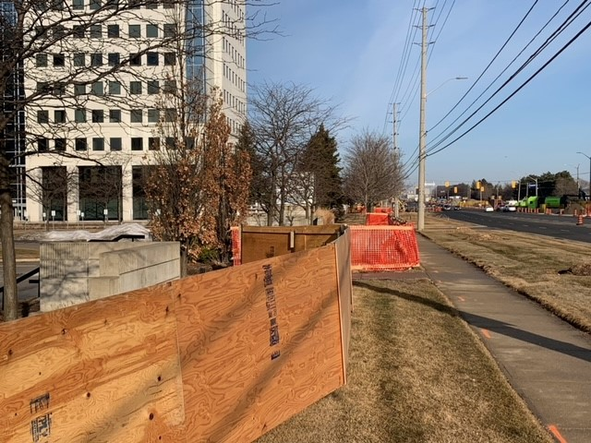Travelling along Hurontario, residents may also notice that work to protect, trim, and/or remove some trees for utility relocations and future streetscaping improvements continue north of Britannia Road. There will be temporary sidewalk closures where tree protection and removal work are taking place. Signage and wayfinding will be in place to help safely navigate through these areas.

**SPRING 2021 VIRTUAL ENGAGEMENT:**

Join us at [metrolinxengage.com/HuLRT](https://www.metrolinxengage.com/en/engagement-initiatives/hurontario-light-rail-transit-project) as we provide project updates and an overview of the construction schedule for the remainder of the year. Ask questions directly to our team of experts through our “Ask Us” section, and your questions will be answered by a member of the project team.

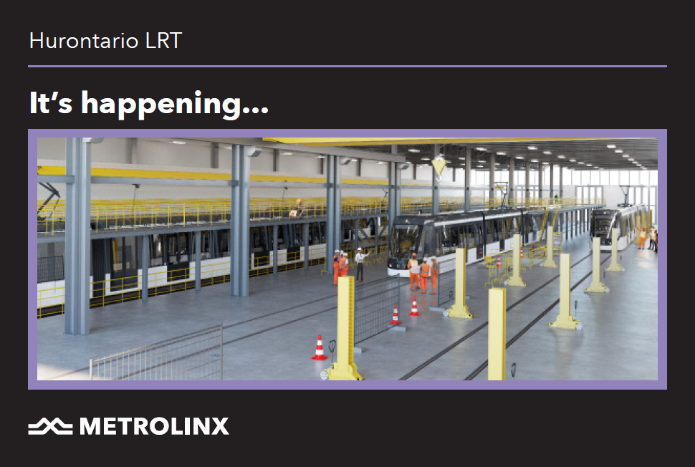

**SAFETY**

Safety is our number one priority and a shared responsibility. Please note and follow construction signage as you walk, cycle or drive along Hurontario Street. If you have any questions or concerns, please feel free to reach out to Metrolinx Community Relations team at 416-202-7500 or email [Peel@metrolinx.com](mailto:Peel@metrolinx.com)

For more updates and information on this project, and to get the latest news on what’s happening in Peel, subscribe to our newsletter: [www.metrolinx.com/hurontariolrt](http://www.metrolinx.com/hurontariolrt)