**CONSTRUCTION LIAISON COMMITTEE UPDATE**

*Mississauga North*

July 2021

Thank you for being part of the Hurontario LRT Construction Liaison Committee.

We will be providing our CLC members with a digital update this month (see below).

Our team is virtually engaging with our committee members and broader public as the Covid-19 restrictions continue.

Our next update will be scheduled for August 2021.

**ONGOING CONSTRUCTION:**

**Utility and Road Work**

* The installation of watermain, storm water, sewage and sanitation are ongoing with excavation and the installation of new watermain occurring between Derry Road and HWY 407. The testing and commissioning of newly installed watermain has been occurring between Matheson Boulevard and Britannia Road.
* The relocation of dry utilities, including telecommunications and electrical infrastructure, is also ongoing between Matheson Boulevard and Derry Road. This includes:
  + The use of a Hydrovac truck that applies high pressure water to safely expose existing utilities without causing damage,
  + Excavating and installing new duct banks to house the new utility cables,
  + Backfilling the exposed trenches and restoring the asphalt that has been disturbed to accommodate the works,
* Installing new electrical poles and their overhead cables along the boulevard,
* As utility works have been completed in stages along Hurontario Street, work to widen the road has commenced from Matheson Boulevard to Brunel Road and Capston Drive to Derry Road. Once the current utility and road works are completed, active lanes of traffic will shift in stages over the next few months to the other side of the road in stages.
* **Eglinton to Matheson**

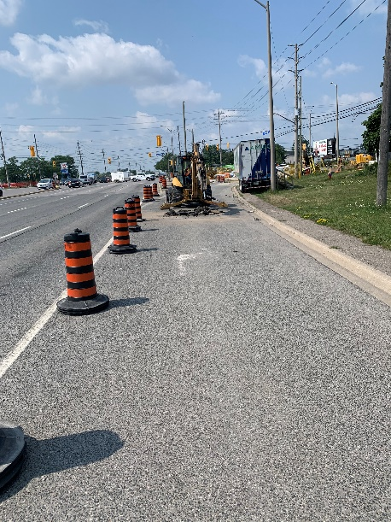 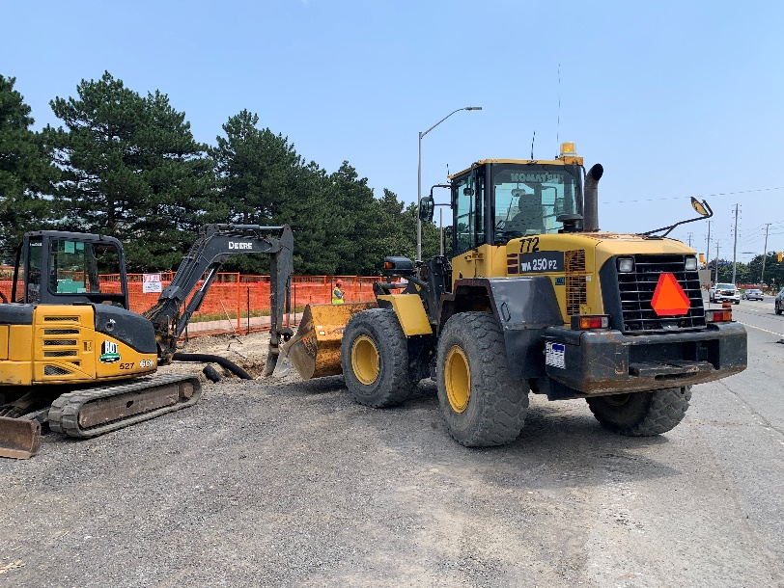

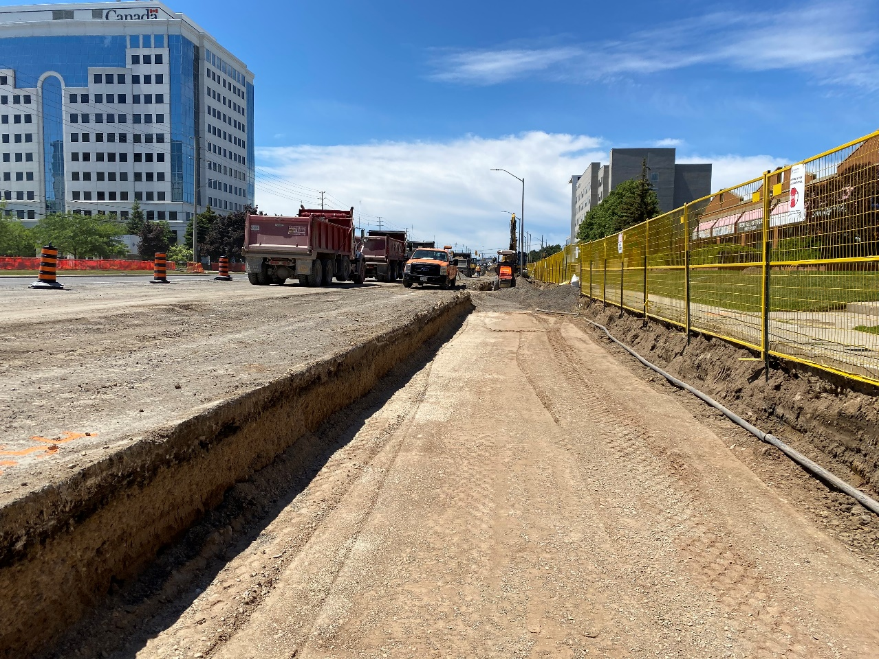

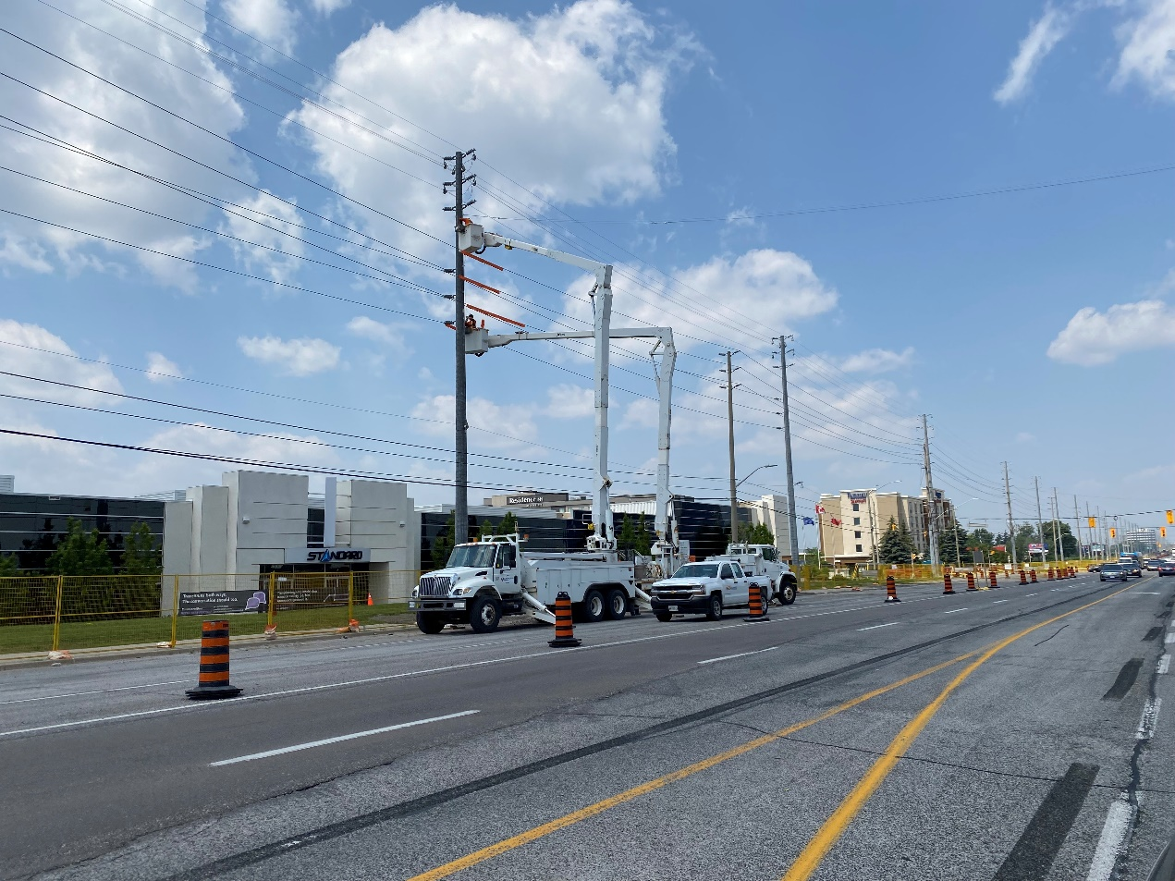

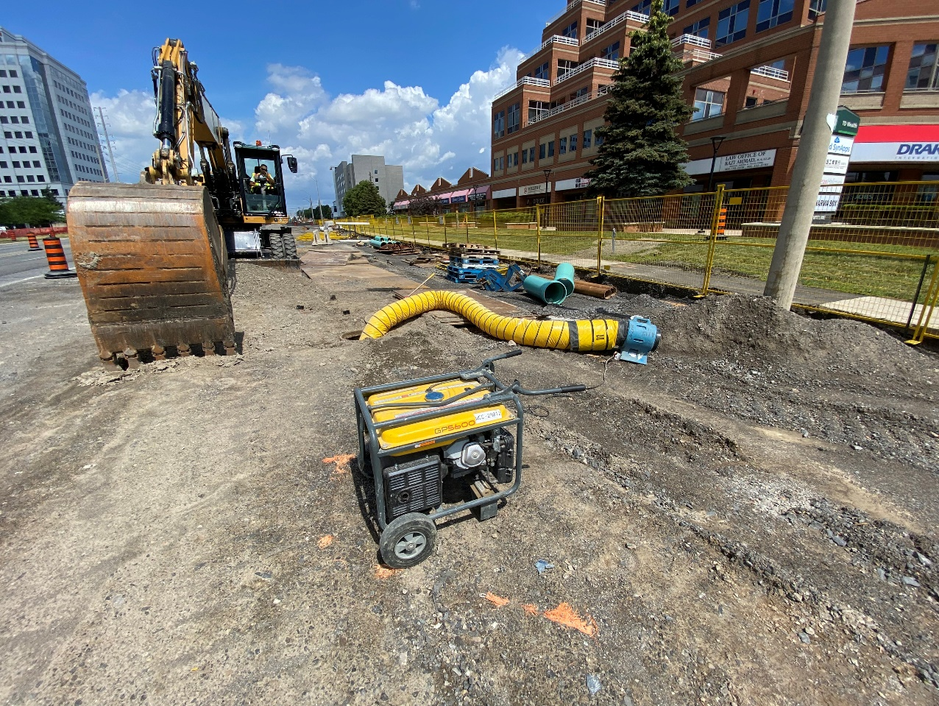

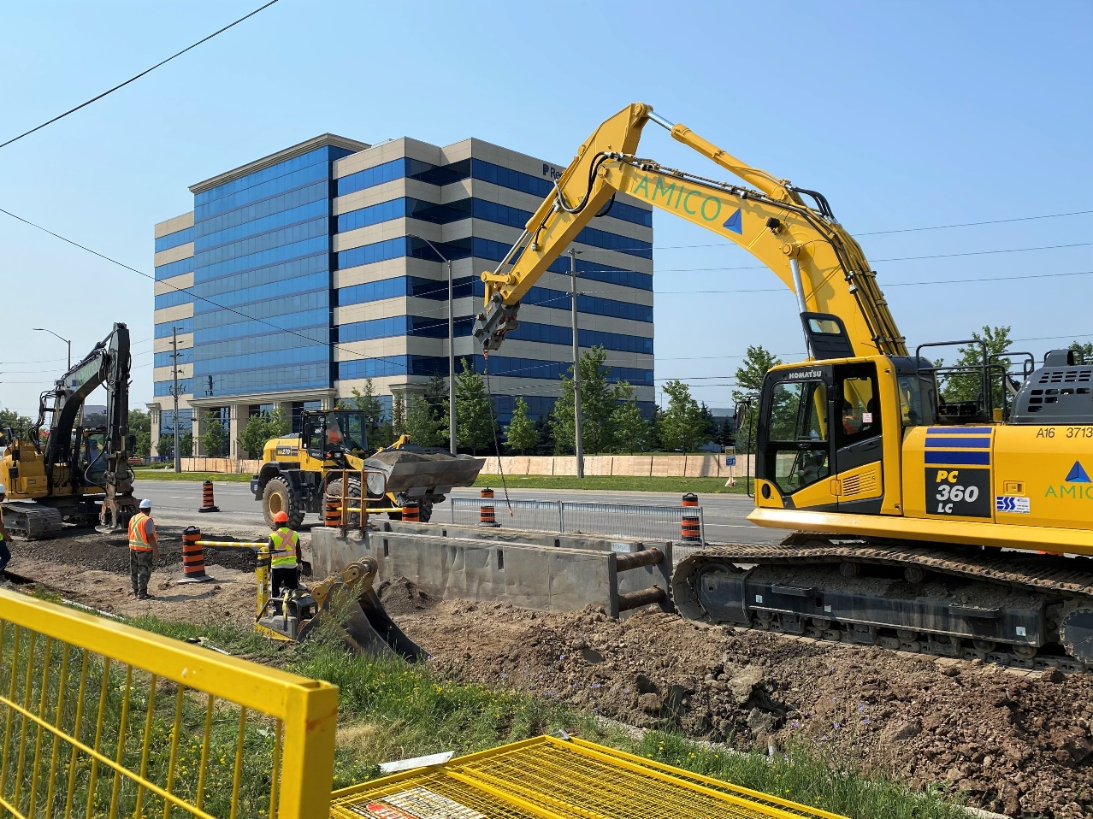

**Topflight Drive**

Work has begun to install new watermains and sewage infrastructure on Topflight Drive.This work is expected to take approximately 8-10 weeks to complete. As a result, access to Topflight Drive will be limited to only traffic travelling west towards Hurontario. Eastbound access to Topflight Drive will be available via Derry Road and Edwards Boulevard. This work may cause some driveway and sidewalk impacts along Topflight Drive and Edwards Boulevard. We will continue to work with private property owners and businesses to minimize the impact and will ensure that only one driveway will be closed at a time, providing options for alternative access.

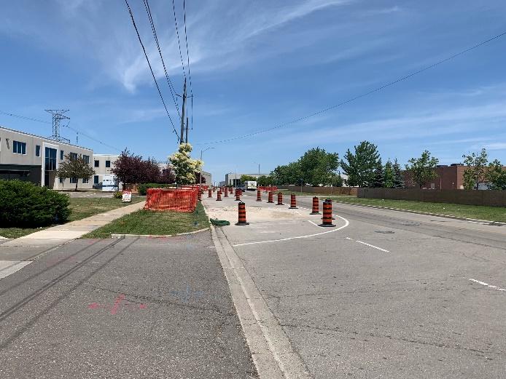 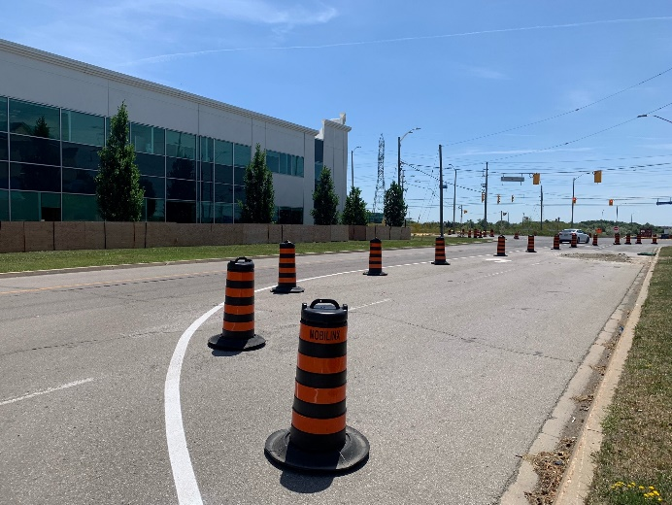

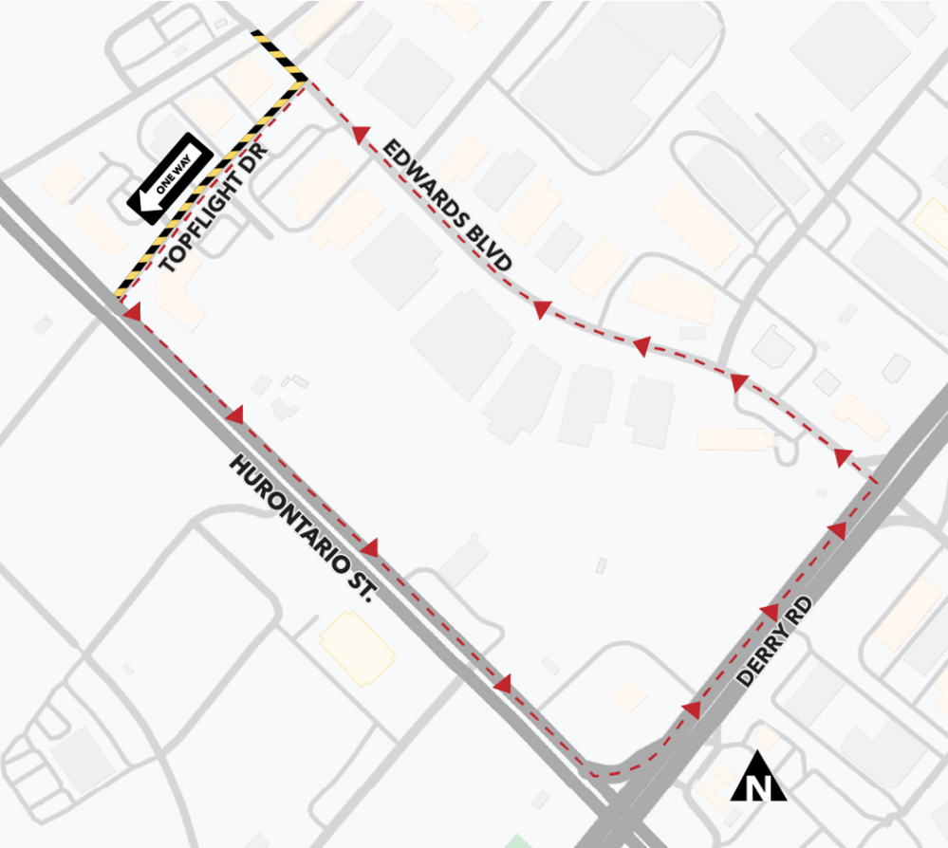

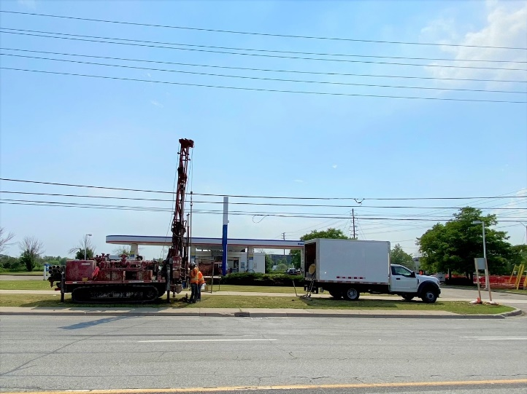

**Environmental Test Pit Investigations:**

The drilling of boreholes for environmental investigations continues on the south side of Derry Road. Environmental investigations analyze the quality of the soil in the area to check for contaminants and determine which facility the excavated soil should be hauled away to during construction.

**Virtual Trade Show – Careers in Construction:**

Last month, Mobilinx launched its second annual Virtual Trade Show at [www.mobilinx.ca](http://www.mobilinx.ca). Visit the Mobilinx website and click on the “Trade Shows” tab at the top of the page to view a pre-recorded video, consisting of presentations from industry experts who provide information on:

* the benefits of a career in the trades
* how to access safety training, and get re-trained
* education and apprenticeships
* how to make yourself stand out from other applicants
* how to advance your career in the trades



**SAFETY**

Safety is our number one priority and a shared responsibility. Please note and follow construction signage as you walk, cycle or drive along Hurontario Street. If you have any questions or concerns, please feel free to reach out to Metrolinx Community Relations team at 416-202-7500 or email [Peel@metrolinx.com](mailto:Peel@metrolinx.com)

For more updates and information on this project, and to get the latest news on what’s happening in Peel, subscribe to our newsletter: [www.metrolinx.com/hurontariolrt](http://www.metrolinx.com/hurontariolrt)