**CONSTRUCTION LIAISON COMMITTEE UPDATE**

*Brampton South*

October 2022

Thank you for continuing your participation in the Hurontario LRT Construction Liaison Committee. We will be providing our CLC members with a digital update this month (see below).

Our next email update will be scheduled for November 2022.

**UPCOMING & ONGOING CONSTRUCTION:**

**QEW Push Box Installation**

At the QEW and Hurontario, a push box will be installed for the Hazel McCallion Line. As the name suggests, it is a large, hollow concrete box that will be pushed into place, forming a new underpass.  
  
This push box will form a new underpass along Hurontario Street for northbound vehicular traffic to accommodate the future LRT and minimize traffic congestion.

From Friday night, Oct. 28 at 10 p.m., to Monday morning, Oct. 31, traffic restrictions will be in place on the Queen Elizabeth Way (QEW) near Hurontario Street in Mississauga, which will be closed between the North Service Road and the South Service Road.

QEW traffic will be reduced to two lanes in each direction and diverted to Hurontario Street before returning to the highway.

To read more about this innovative technology and impacts to the community, please see visit our blog [here.](https://blog.metrolinx.com/2022/10/13/weekend-restrictions-on-qew-partial-closure-of-hurontario/)

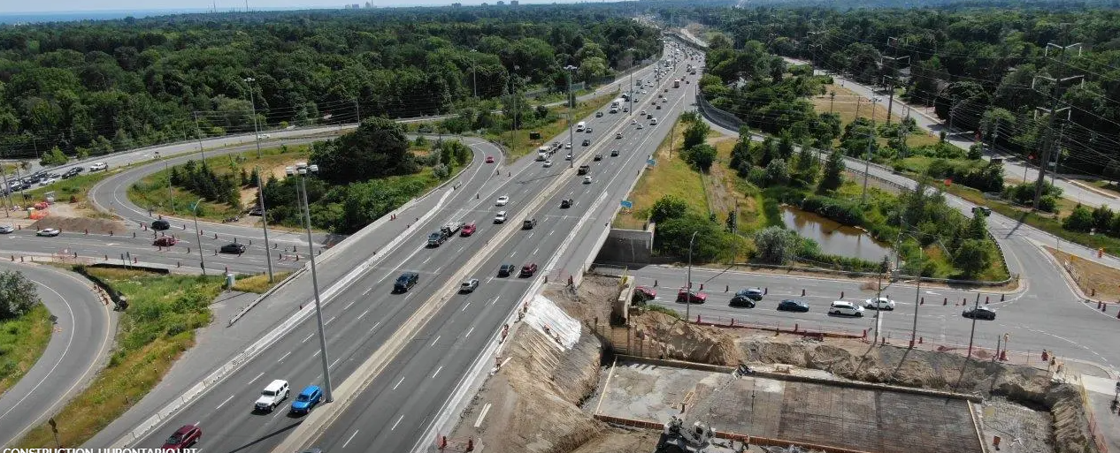

**Utilities and Roadways**

Construction staging expands along Hurontario Street as utility relocations, storm installations and ductbank installations continue.  These works may take place overnight.  They will prepare crews for guideway and track installations that will take place in the centre of the roadway.

The concrete foundation for the Overhead Catenary System (OCS) poles has been drilled and poured.  Once installed, OCS will conduct power to the Light Rail Vehicles (LRVs) as they provide service along the corridor.

Working with an arborist to determine any tree impacts as construction moves forward, the team collaborates with the municipal authorities to ensure proper arboriculture techniques are employed and to confirm protection or removal requirements for trees located along the boulevard. These requirements have been developed by a certified arborist in consultation with the City of Brampton and Metrolinx.

Every reasonable attempt has been made to protect the trees we can as well as to reduce the need for tree removals. To minimize the impacts of construction on the natural environment, Mobilinx has fenced off public trees that have been identified by an arborist for protection. Municipal or private trees that need to be removed will be replaced in accordance with the City of Brampton permit requirements. We will continue to work with private property owners on an individual basis for private tree impacts that have been identified on their property.

As utility works progress along the corridor, there will be temporary road and driveway closures at adjacent properties in order to install utilities that cross them. Please note that only one driveway will be impacted at a time, wherever possible, and we are working with property and business owners to minimize the impact.

We encourage motorists to plan for delays. We recommend entering properties by turning right in and exiting properties by turning right out. Please follow the signage in place and do not use private laneways and plaza parking lots as detour routes.

**OMSF**

The Hurontario light rail transit’s (HuLRT) Operations, Maintenance and Storage Facility (OMSF) is nearing completion!  The offices and control rooms have been completed.  Most of the furniture has been installed and arranged. Crews are completing finishes, like painting, and works are currently taking place on the ground floor around the interior tracks. Concrete foundations, elevator construction, and glazing are complete, and the raised platform used to access the top of the light rail vehicles is currently being installed and painted.

Outside the OMSF building, track installation and welding of rail continue westbound to Hurontario.  Staging for sanitary connections continues along Kennedy Road.  Support signage for businesses has been installed to provide added visibility. OCS pole foundation work is ongoing.

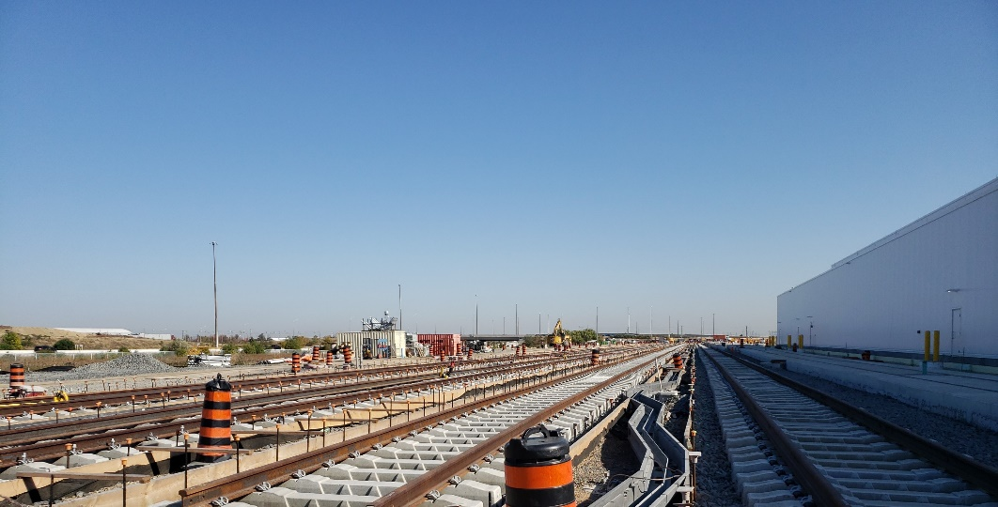

**COMMUNITY ENGAGEMENT**

**Canvass**

Our community canvassers successfully completed the yearly large-scale canvass for 2022. They connected with hundreds of residents, businesses and transit users on the corridor and gathered important feedback. The canvassers knocked on more than 3,838 doors and distributed over 4,200 pieces of information material. Eighty seven percent of the respondents said they receive great or adequate information about the project in a timely manner. Seventy nine percent of respondents at temporary bus platforms said that they are satisfied with the safety and accessibility of these platforms. We thank everyone who participated in the survey.

**Out in the Community**

The Peel Community Engagement Team partnered with the Hurontario LRT Project team to take part in an amazing Tree Planting event hosted by the Credit Valley Conservation (CVC) at Spruce Park! We learned about the importance of trees and our environment by planting 125 native trees and shrubs and 50 wildflowers alongside expert CVC staff.

Spruce Park is located next to the Hurontario LRT alignment in South Mississauga. This neighborhood has been quite upset with the removal of trees along the Hurontario LRT corridor, and it continues to be an ongoing concern as construction progresses. Although a tree replacement program is in place as part of the work along the corridor, our Peel Community Engagement team took it a step further as a good community neighbor, to support the development of the tree canopy in this area of Mississauga through this tree planting event. This event provided us an opportunity to show the community we care about trees and the environment and are dedicated their neighborhood.

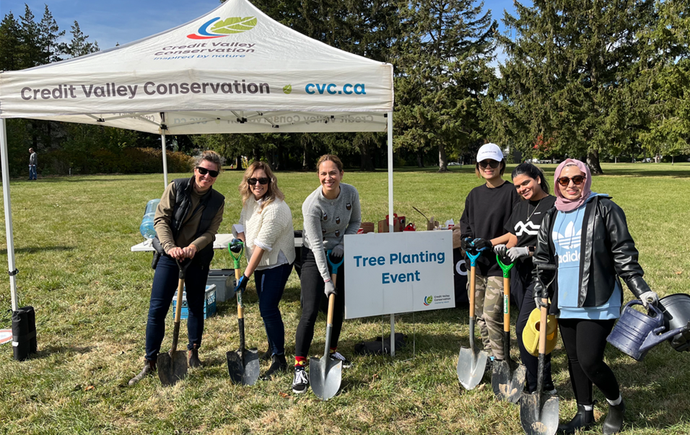

**Transit in Your Community School Engagement**  
The Peel team is excited to host Transit in your Community presentations in the coming weeks. This program allows students to learn about projects that are currently being built, those in the transit planning process, as well as how we work with our municipal partners on some of these projects. We look forward to creating learning opportunities for outreach and engagement with children, their parents and the community to keep our future riders, and the community informed and aware.

**Safety**

Safety is our number one priority and a shared responsibility. Please note and follow construction signage as you walk, cycle or drive along Hurontario Street. Pedestrians are advised to only cross at signalized intersections and always walk on designated pathways.

**3,000,000 Hours Without a Lost Time Injury**

As of October 12th, Metrolinx and its construction partner, Mobilinx, have completed more than three million hours of work without a lost time injury. A lost time injury, also referred to as an LTI, refers to any incident that results in a disability or an employee missing work due to an injury. It is an important key safety indicator for any construction project.   
  
We are serious about our safety mindset, as we are fully aware that people are our greatest asset. We believe Health and Safety is a moral and ethical responsibility and that's why we strive for the highest standards and best practices when it comes to safety.   
  
We are celebrating this accomplishment and want to thank all of our construction staff and workers for their commitment in maintaining a safe and healthy workplace.

**Contact Us**  
If you have any questions or concerns, please feel free to reach out to Metrolinx Community Relations team at 416-202-7500 or email [Peel@metrolinx.com](mailto:Peel@metrolinx.com)

For more updates and information on this project, and to get the latest news on what’s happening in Peel, subscribe to our newsletter: [www.metrolinx.com/hurontariolrt](http://www.metrolinx.com/hurontariolrt)