**CONSTRUCTION LIAISON COMMITTEE UPDATE**

December 2022

Thank you for continuing your participation in the Hurontario LRT Construction Liaison Committee. We will be providing our CLC members with a digital update this month (see below).

We look forward to resuming virtual meetings in the new year.

**SAFETY WALKS in 2023**

Safety is our number one priority and a shared responsibility. We would like to invite our CLC members to join our team on a safety walk of their corridor segment to observe construction and help identify where and how Metrolinx is able to improve safety for the community.

Corridor segments can be quite long, we look forward to hearing your suggestions for the best location for our safety walk.

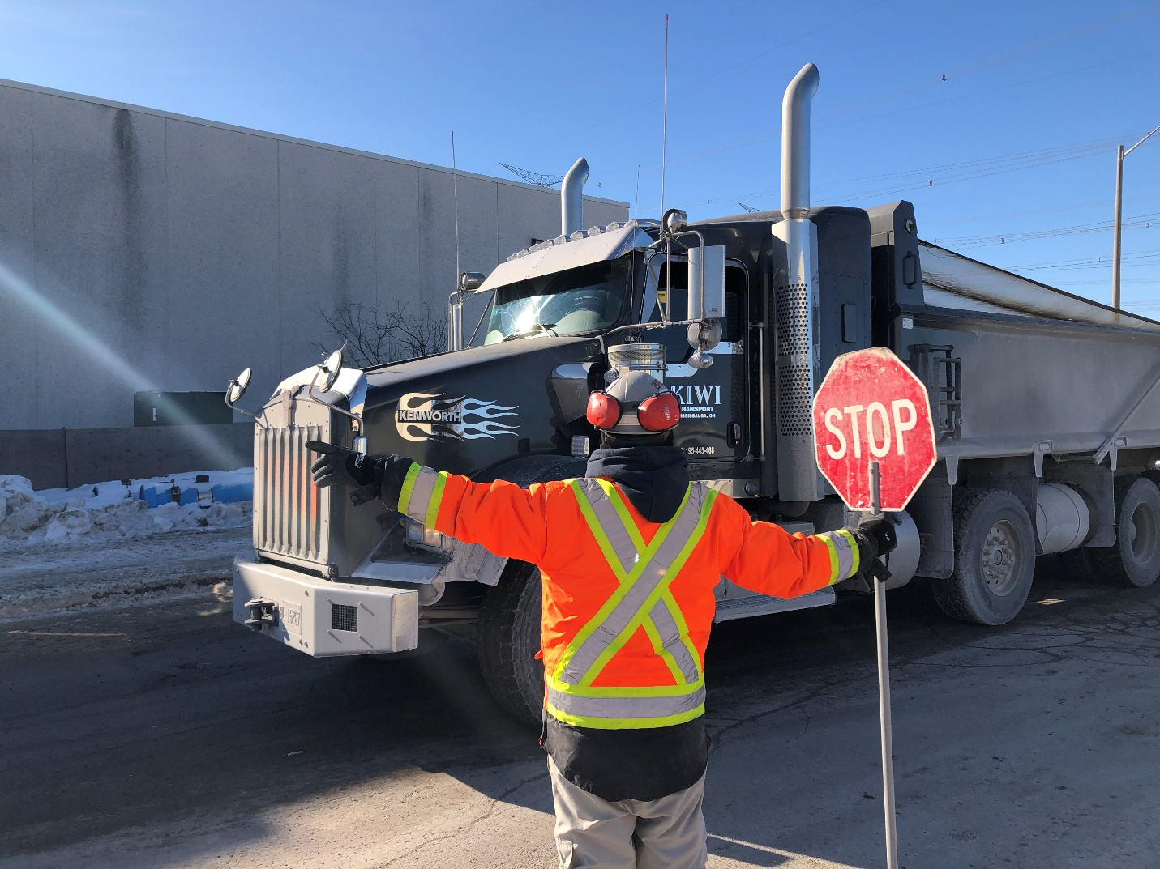

**ONGOING and UPCOMING CONSTRUCTION:**

As the 2022 construction year nears completion, crews remain busy along the entire project corridor before shutting down for the holidays at the end of day on **December 23, 2022**, to return on **January 3, 2023**. Here’s a snapshot of construction activity you can expect until the new year:

* Construction of service level wall continues at Port Credit Station.
* Work on the abutments of Eaglewood Bridge continue.
* Alectra duct bank works continue between Mineola Road and Pinewood Trail and between Harborn Road and Burnhamthorpe Road.
* Wet utility works, including storm, sanitary, and watermain are currently concentrated between Hillcrest Avenue and Eglinton Avenue.
* 23 girders have been installed so far for the elevated guideway.
* Road widening continues between Kingsway Drive to Topflight Drive.

**2022 MILESTONE RECAP**

As 2022 draws to a close, we’d like to take this opportunity to reflect on a remarkable year for the Hazel McCallion line. Having managed the many challenges brought by the COVID-19 pandemic over the past two years, 2022 marked a return to a new normality and the steady progression of construction along the Hurontario corridor.

**Operations, Maintenance and Storage Facility (OMSF)**

Work at the Operations, Maintenance and Storage Facility (OMSF) progressed significantly in 2022. The OMSF will be the hub of the new LRT transit line, with vehicles travelling along Topflight Drive and over a new bridge spanning Etobicoke Creek to reach the OMSF.

Inside the building, there’s a repair shop, vehicle cleaning facility, material storage, and capacity for 42 light rail vehicles being built by Alstom. Most of this construction is now complete.

Tracks were installed in the OMSF yard and building while construction wrapped up, along with mechanical and electrical works and finishings. The raised platform used to access the top of the light rail vehicles was also installed and painted.

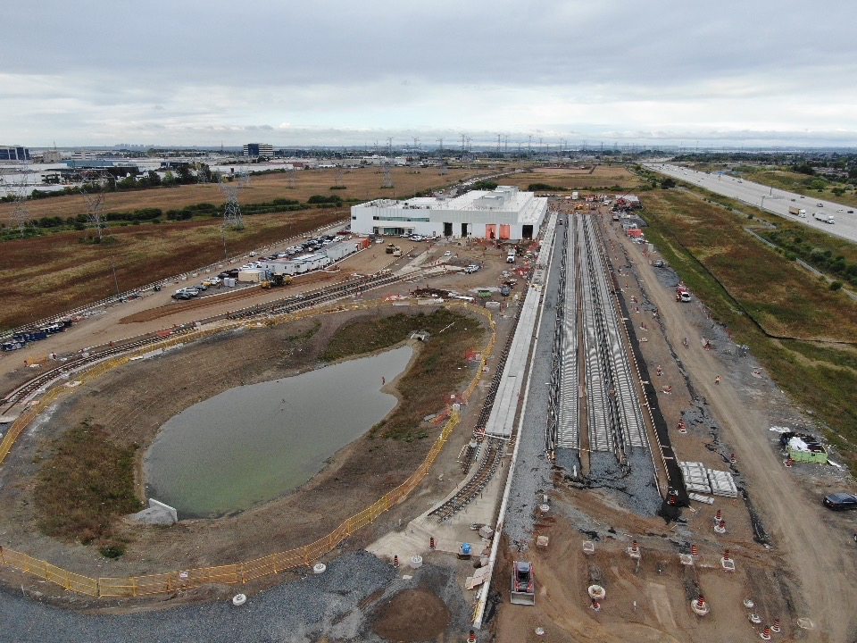

**Guideway and track construction**

Installing tracks along the roadway isn’t as simple as affixing rails to the ground. Crews first need to dig the roadway up, then dig down as deep as five feet to install the foundation of the guideway.

With track work at several intersections now complete including:

* Hurontario Street & Sandstone Drive/Brunel Road
* Hurontario Street & Milverton Drive/ Watline Avenue
* Hurontario Street & Aldridge Street/Traders Boulevard

There is steady momentum for track installation going into the new year.

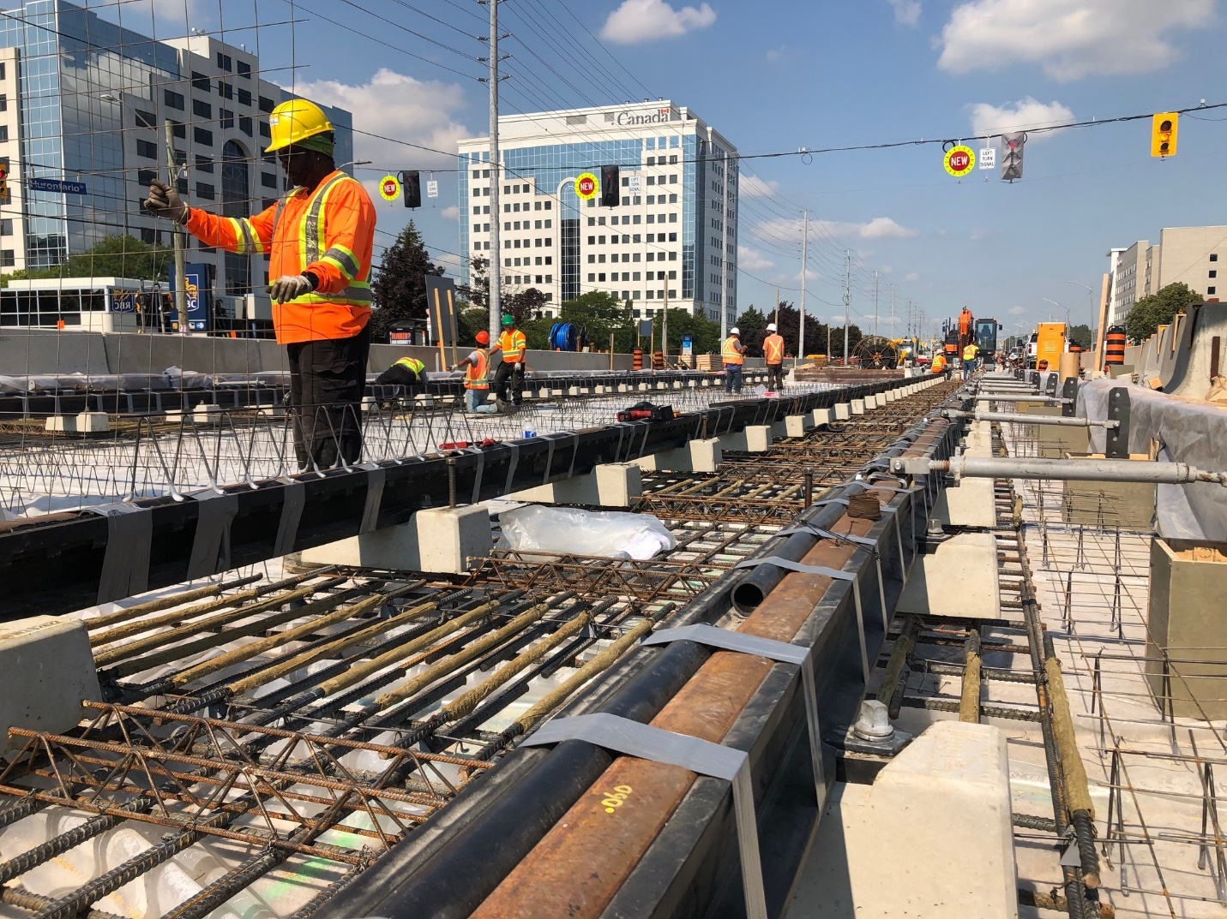

**Queen Elizabeth Way (QEW) push box**

Over a single weekend, crews installed a new underpass under the Queen Elizabeth Way (QEW) at Hurontario Street. The process involved using hydraulic jacks to push a push box weighing more than 6,000 tonnes into place.

The QEW push box will be the permanent underpass for northbound Hurontario traffic, allowing space for the Hazel McCallion Line tracks through the existing underpass along with the southbound Hurontario traffic.

In classic Canadian fashion, a lucky toonie was added to the underpass structure during the push and it did its job as the push was completed to plan, safely and successfully. Now, it will forever be part of the new underpass, bringing future LRT passengers good luck.

**Port Credit GO push box**

Hurontario Street is seeing many firsts. After more than a year of preparatory work, crews building the Hazel McCallion line started the official push of a large concrete structure, or push box, underneath the Lakeshore West rail tracks at the Port Credit GO Station using the groundbreaking Verona System in a very first on Canadian soil. This push started in November and will wrap up in 2023.

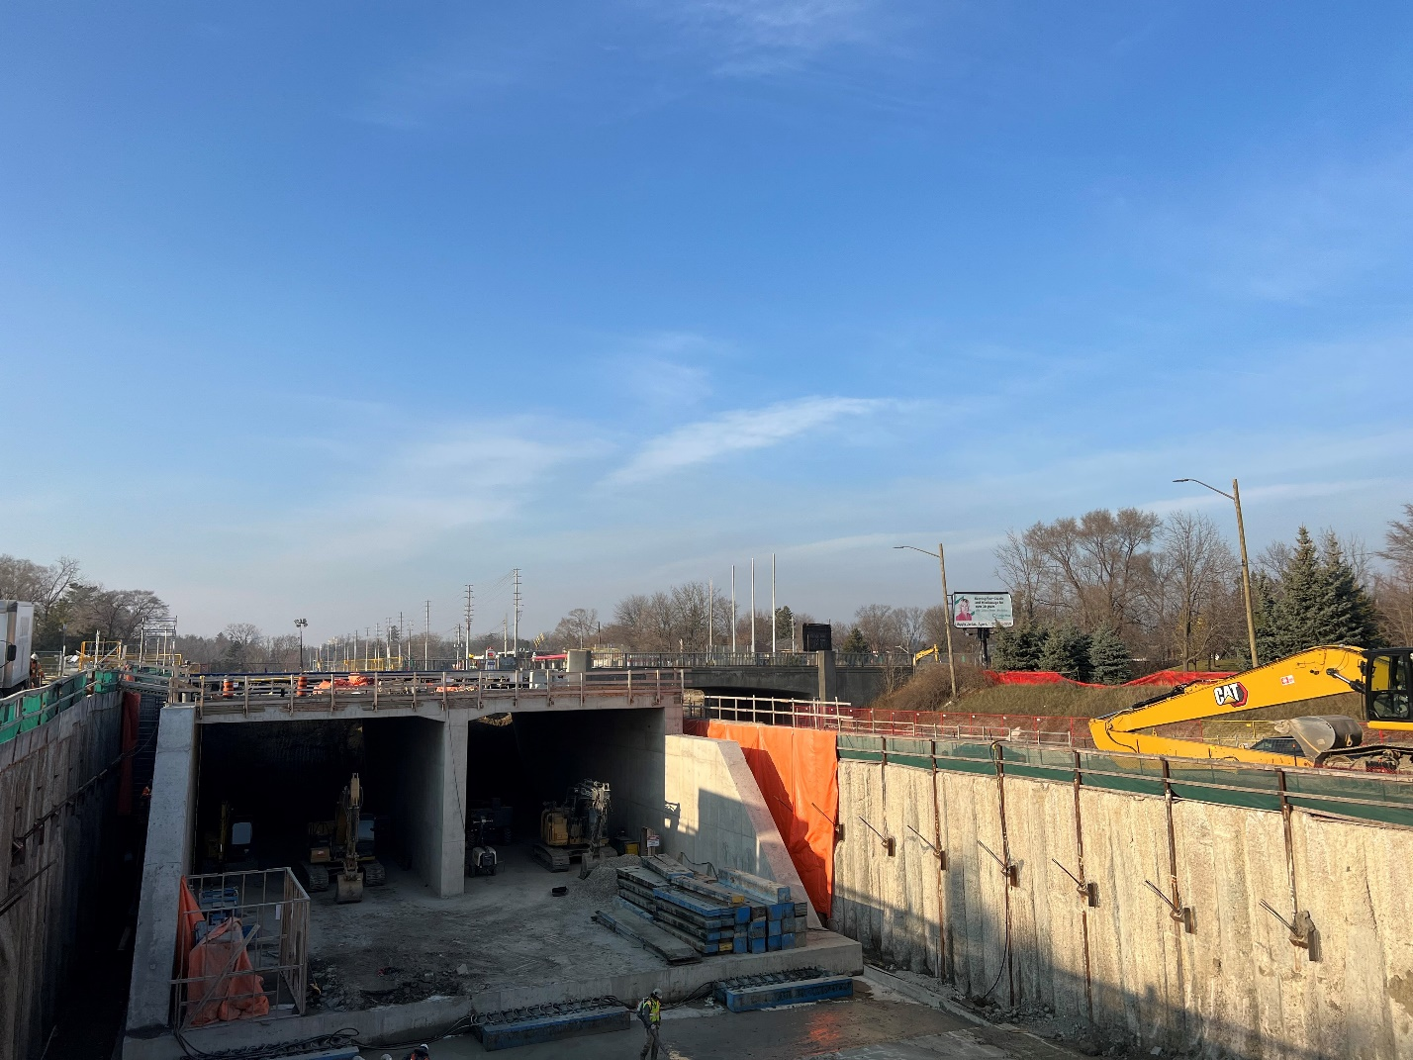

**403 Flyover Progress**

One of the more interesting parts of the Hazel McCallion LRT will be a new flyover bridge to allow the LRT to cross Highway 403.

This new structure will give the LRT its own route over the 403, minimizing any disruptions to vehicle traffic. The support columns and caps are being installed now, and the first girders of the new bridge are being put into place.

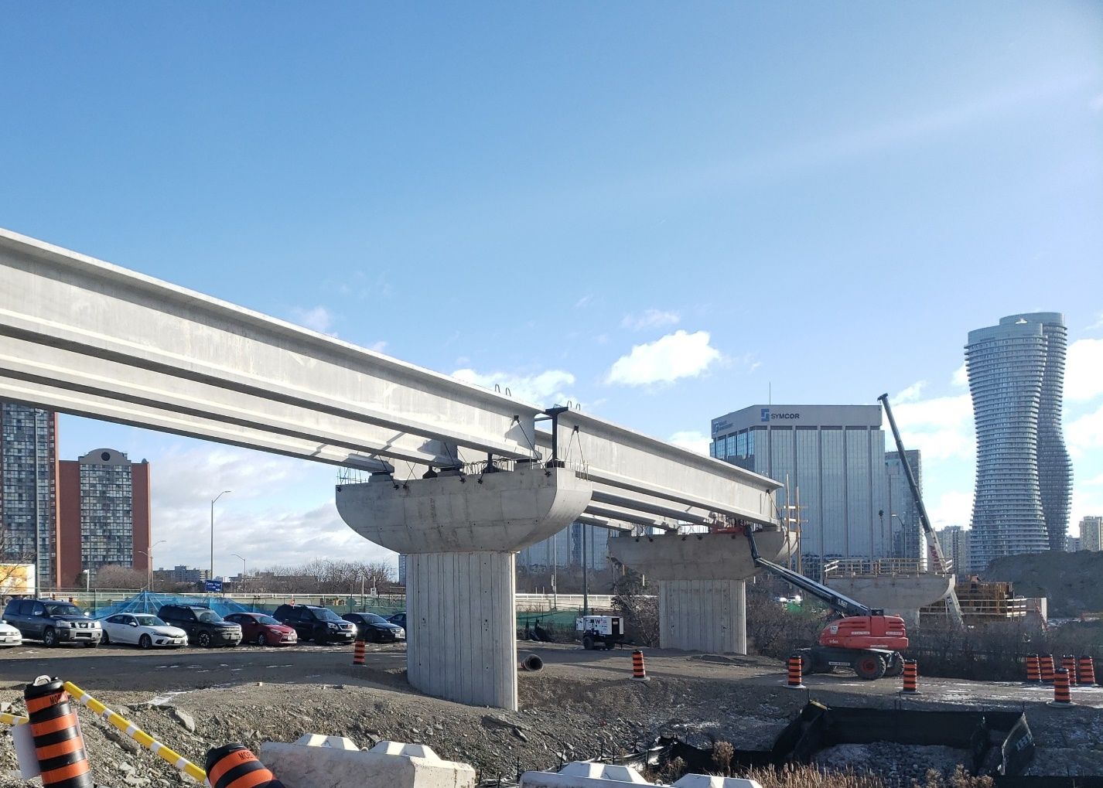

**Loss Time Injury Milestone**

As of October 12, Mobilinx (the constructor of the Hazel McCallion LRT) has completed more than three million hours of work without a lost time injury (LTI).

A LTI is any incident that results in a disability or an employee missing work due to an injury. It’s an important key safety indicator in any construction project.

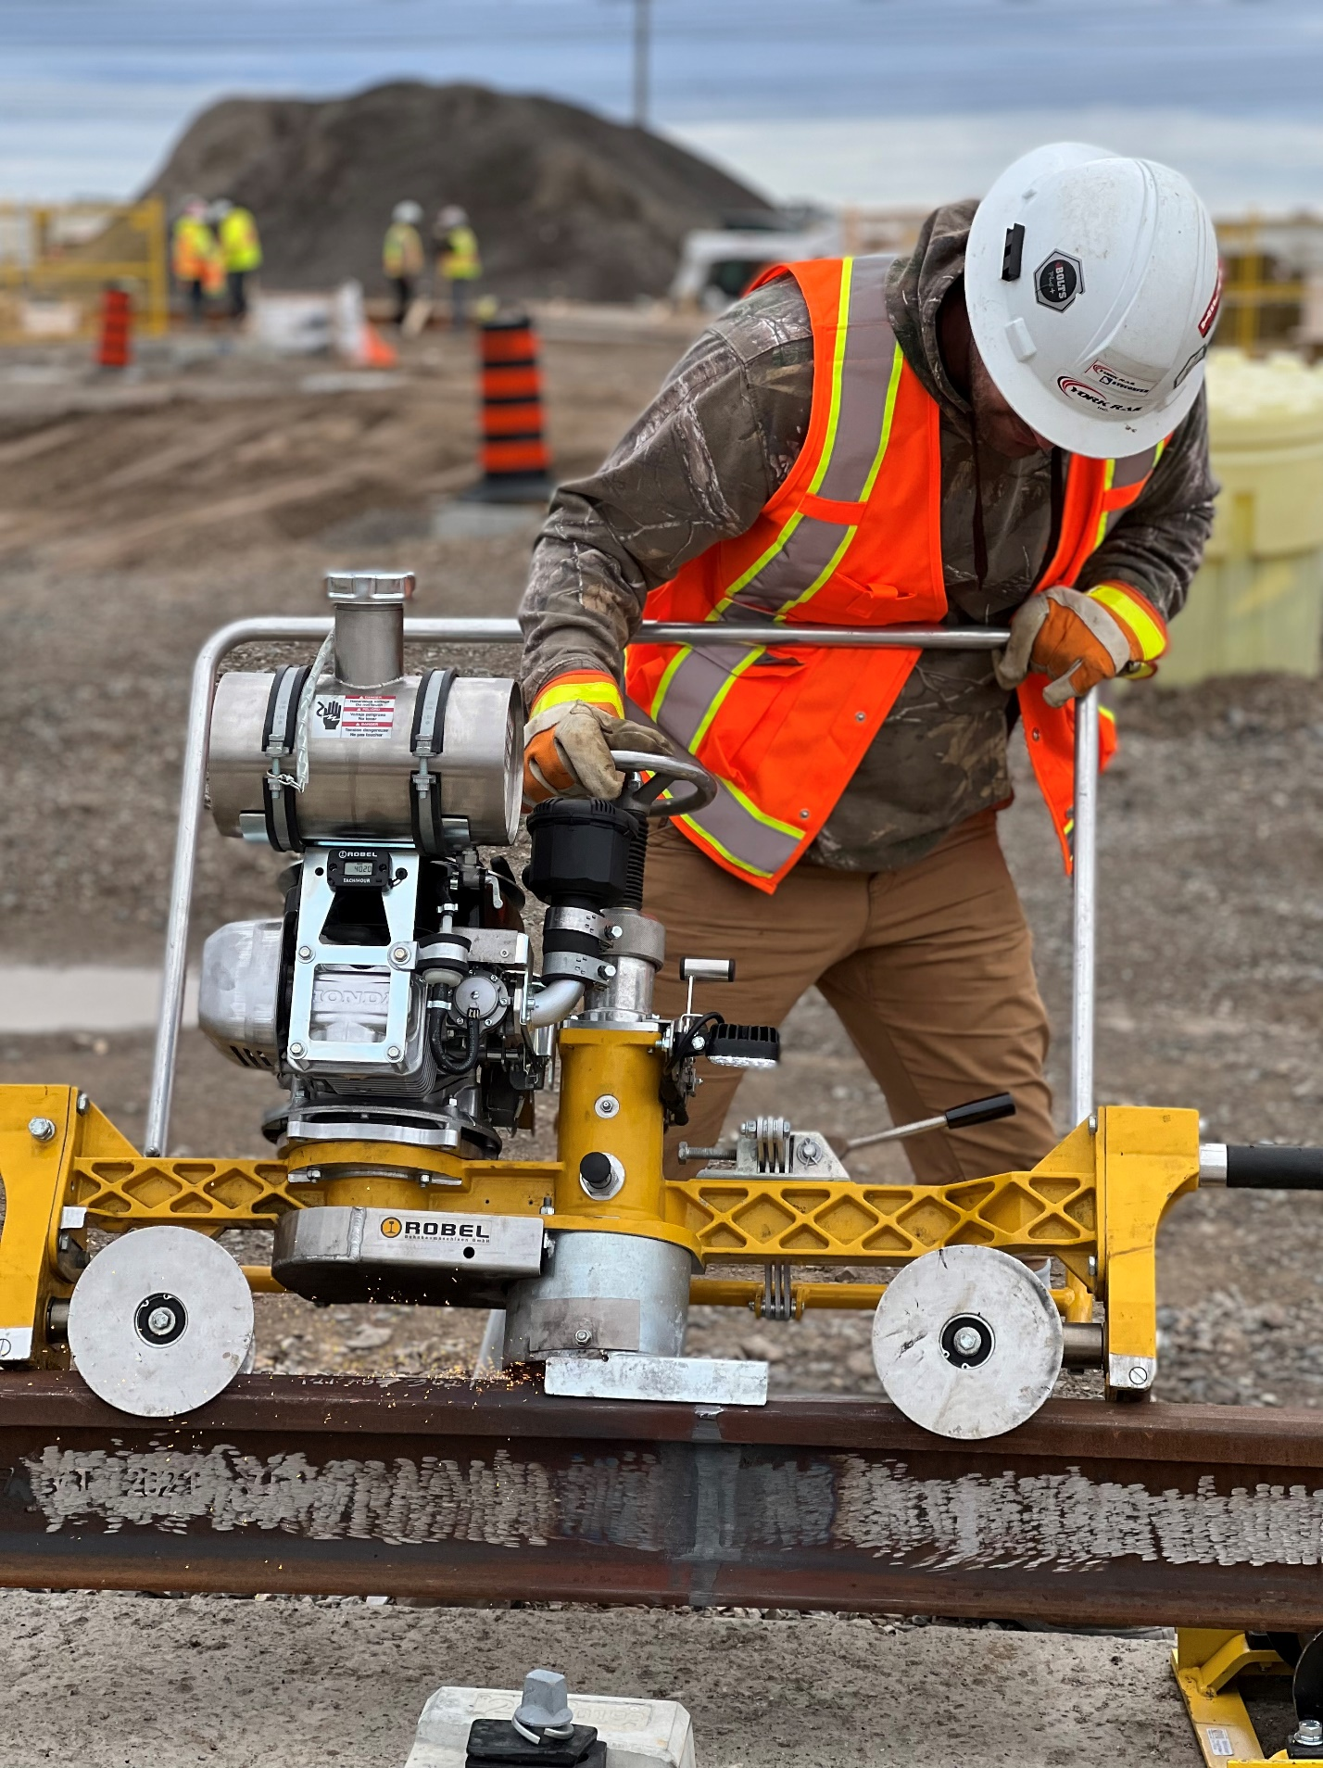

Read more on Metrolinx News. Link to blog article.

**Contact Us**

If you have any questions or concerns, please feel free to reach out to Metrolinx Community Relations team at 416-202-7500 or email [Peel@metrolinx.com](mailto:Peel@metrolinx.com)

For more updates and information on this project, and to get the latest news on what’s happening in Peel, subscribe to our newsletter: [www.metrolinx.com/hurontariolrt](http://www.metrolinx.com/hurontariolrt)