Dear Committee Members,

We’re pleased to share our Spring 2026 update and provide a look at the exciting work ahead across the corridor. We’re happy to see continued progression across all segments of the project and are encouraged by the upcoming work plan, which will help advance key infrastructure and move us closer to train testing.

Below is a detailed recap and lookahead for each area.

Mississauga South
Recap
- Electrical poles have been successfully installed throughout the area.
- The majority of electrical and telecommunications connections have now been completed.
- Guideway works have commenced south of Mineola Road, marking an important milestone.
- Roadworks on the west side between Eaglewood Drive and Pinetree Way have been completed.
- Bronte College Court intersection track installation expected to be completed in May.
Lookahead
- Trackwork will begin north of Indian Valley Trail in the coming weeks.
- Road widening will take place on the east side from south of Mineola Drive to Eaglewood Drive.
- Dry utilities crews will continue telecommunications work at the northeast corner of the QEW.
- Guideway construction will proceed under the QEW interchange.
- Intersections in the area will transition to Stage 4 configurations.
- Track intersection works will be carried out within the QEW area.

Mississauga Cooksville
Recap
- The Traction Power Substation (TPSS) has been installed at the northeast corner of Hurontario Street and Dundas Street.
- Tracks have been installed within the intersections at Hillcrest Avenue and King Street.
- A power switchover was completed at the THP facility.
Lookahead
- Electrical works will continue between John Street and Fairview Road.
- Pole installations will proceed across the segment.
- Telecommunications installations will continue.
- Trackwork activities will remain ongoing in the area.
- Electrical works near Dundas Street will advance.
- Alectra installations at King Street will continue.
- Power supply connections to the TPSS at Dundas Street and Hurontario Street will be completed.

Mississauga Centre
Recap
- Majority of foundational work for the elevated guideway has been completed.
- Lightweight fill installation has been finalized.
- Bus shelters along Burnhamthorpe Road have been reinstated.
- Rehabilitation of the Highway 403 bridge along Hurontario Street has been conducted.
Lookahead
- Work will continue at the TPSS site at Kingsbridge.
- Trackwork activities in the area will proceed.
- Elevated guideway construction will continue, including backfill and mud slab pours. The area will soon be turned over for track installation.
- Futureproofing works along Rathburn Avenue and construction at the Mississauga City Centre Stop (Station Gate and Rathburn) will advance.
- Electrical connections to new infrastructure will be completed.
- Streetlight installations and connections will continue.

Mississauga North
Recap
- Canopy installations have been completed at Bristol, Britannia, Matheson, Courtneypark, Derry, and Eglinton stops.
- TPSS cable pulling activities have been conducted.
- Bus stops at Matheson, Courtneypark, Derry, and surrounding areas have been reinstated.
- Track installations have progressed.
- Permanent signal infrastructure at Topflight has been energized.
Lookahead
- Dry utilities installations, including telecommunications work, will continue.
- Trackwork will proceed on the Highway 401 overpass.
- K-frame installations at the Highway 401 bridge will continue.
- Existing hydro poles will be removed.
- Permanent traffic light installations and energizations will take place at Kingsway, Ambassador, Derry, Admiral, Superior, Count, and Topflight.
- TPSS energizations will be carried out.

Brampton
Recap
- The new Highway 407 northbound overpass has opened.
- Storm sewer upgrades have been completed in key areas.
- Guideway excavation activities have progressed.
- Delivery of the TPSS at the southwest corner of Steeles Avenue and Hurontario Street has been completed.
- Curb installations have advanced.
Lookahead
- Storm sewer upgrades will continue.
- Alectra upgrades to private properties will proceed.
- Guideway installations will continue.
- Streetlight relocations will be undertaken.

Safety across the corridor

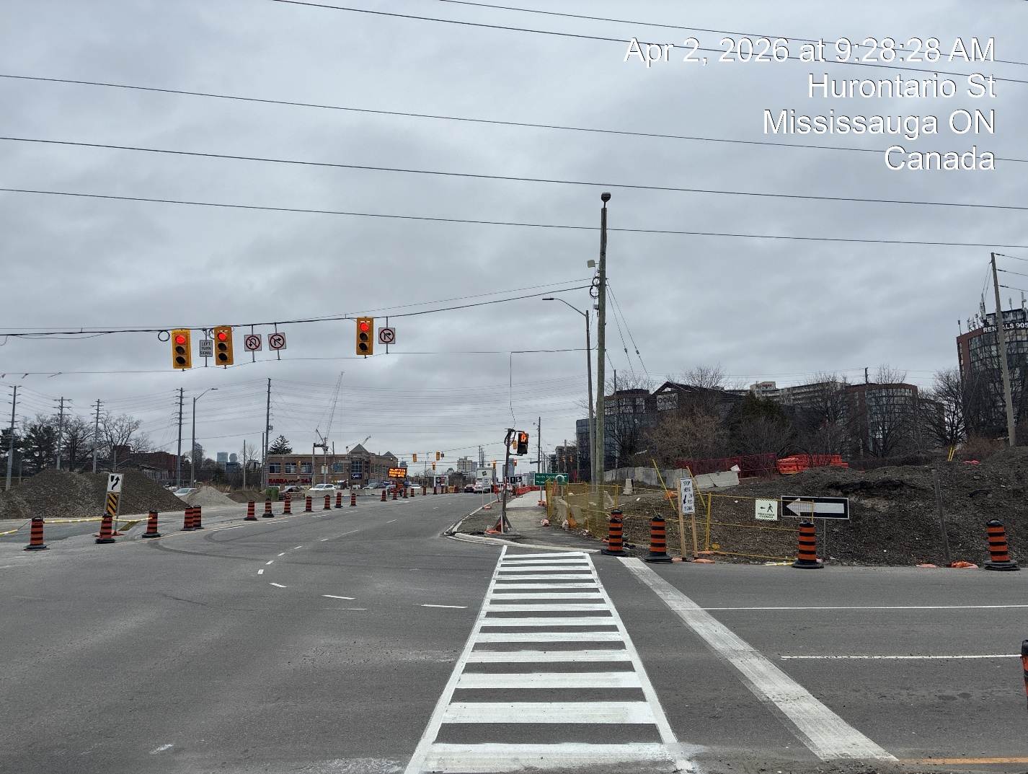

The safety of pedestrians and the public continue to be a priority. We are reviewing site conditions across the corridor, assessing current traffic configurations, and identifying additional measures that may help improve conditions for our communities, as we have done throughout the project construction lifecycle, and will continue to do.

Some measures include:
- Community safety walks which have been conducted in collaboration with Project Delivery and Safety Standards teams to identify and address site-specific risks.
- Targeted safety blitzes in school zones, to promote safe crossing behaviours and increase awareness among students and families.
- AODA compliance inspections to ensure accessible and safe pedestrian infrastructure is maintained throughout construction.
- “Transit in Your Community” school presentations, focused on educating students about construction safety and transit awareness.
- Digital and social media campaigns, including video content to reinforce safety messaging across a broader audience.
- Routine site inspections to identify opportunities for enhanced safety measures, such as additional fencing and barriers.
- Line painting refreshes to improve visibility and support both pedestrian and driver safety.
- Enhanced pedestrian access and detour signage, particularly in high-traffic areas, to support safe navigation around construction zones.

We are encouraged by the steady momentum across the corridor and excited to see the upcoming work plan continue to move the project forward, with increasing focus on infrastructure readiness and train testing preparation.

We are also planning to resume in-person Construction Liaison Committee meetings in the near future and will be in touch soon to coordinate scheduling details.

Thank you, as always, for your ongoing partnership and commitment to keeping your communities informed.

Peel Community Engagement Team
(416)-202-7500
peel@metrolinx.com
3024 Hurontario St, Unit G12, Mississauga

